**PGPDSE FT-Project**

**Title: Zomato Case Study**

**Submitted By:**

**Gayatri Jitendra Patil**

**Industry Review**:

Zomato is an Indian multinational restaurant aggregator and food delivery company that was founded in 2008 by Deepinder Goyal and Pankaj Chaddah. The company is headquartered in Gurugram, India, and has a presence in over 24 countries, including India, the United States, Canada, and Australia.

Zomato's main offering is its restaurant discovery and food delivery platform, which allows users to search for and discover restaurants in their area, view menus, and read reviews from other users. In addition to these features, Zomato also offers online ordering and food delivery services from select partner restaurants.

Zomato's platform is designed to help users make informed decisions about where to eat and what to order. Its vast database of restaurant information, menus, and user reviews makes it a valuable resource for foodies and diners looking for new dining experiences.

Over the years, Zomato has expanded its services to include a range of other features and offerings. In 2015, the company launched Zomato Book, a restaurant reservation platform that allows users to book tables at participating restaurants. In 2017, Zomato acquired Runner, a hyperlocal logistics company, which helped the company expand its food delivery services.

In recent years, Zomato has also focused on expanding its international presence. The company has entered new markets through a combination of organic growth and strategic acquisitions, including the acquisition of Uber Eats India in 2020.

In summary, Zomato is a restaurant aggregator and food delivery company that provides users with information, menus, and user reviews of restaurants, as well as food delivery options from select partner restaurants. With a presence in over 24 countries, Zomato is a valuable resource for foodies and diners looking for new dining experiences.

**About the Data:**

Zomato is an Indian multinational restaurant aggregator and food delivery company founded by Deepinder Goyal and Pankaj Chaddah in 2008. Zomato provides information, menus, and user reviews of restaurants as well as food delivery options from partner restaurants in select cities.

**Problem Statement:**

Zomato is an Indian company that provides a platform for users to search for and discover restaurants, as well as order food for delivery. It was founded in 2008 by Deepinder Goyal and Pankaj Chaddah and has since expanded to multiple countries around the world. Zomato provides users with information about restaurants such as menus, prices, and user reviews to help them make informed decisions about where to eat. The company also partners with restaurants to offer food delivery options to customers

**Dataset and Domain :**

**Data Dictionary :**

1. URL - Website of the Zomato for each restaurant. - Object datatype
2. Address - Address of the Restaurant. - Object datatype
3. Name - Name of the restaurant. - Object datatype
4. Online Order - The customer ordered the menu online or not. - Object datatype
5. Book table - The customer has booked the table or not. - Object datatype
6. Rate - Rating of the restaurant that has by the customer. - Numerical datatype
7. Votes - The votes have been given by the customer to the restaurant. - Numerical datatype
8. Phone - Contact number of the Restaurant. - Object datatype
9. Location - The city name where the restaurant is located. - Object datatype
10. Rest Type - The type of restaurant. - Object datatype
11. Dish liked - Dishes liked by the customer from the restaurant. - Object datatype
12. Cuisines - The cuisines that have been prepared by the restaurant. - Object datatype
13. Approx Cost for two people - The approximate cost of the customer for 2 people. -

Number datatype

1. Reviews list - The reviews made by the customers on the restaurant. - Object datatype
2. Menu Item - The menu items that are usually available at the restaurant. - Object datatype
3. Listed in (type) - Contains the type of the meal. - Object datatype
4. Listed in (city) - This contains the neighborhood in which the restaurant is listed. -

**Selection A:**

**Problem:**

Restaurants from all over the world can be found here in Bengaluru. From the United States to Japan, Russia to Antarctica, you get all types of cuisines here.

Delivery, Dine-out, Pubs, Bars, Drinks, Buffet, Desserts you name it and Bengaluru has it. Bengaluru is the best place for foodies. The number of restaurants is increasing day by day. Currently, it stands at approximately 12,000 restaurants. With such a high number of restaurants. This industry hasn't been saturated yet. And new restaurants are opening every day. However, it has become difficult for them to compete with already established restaurants. The key issues that continue to pose a challenge to them include high real estate costs, rising food costs, shortage of quality manpower, fragmented supply chain, and over-licensing.

**Objective:**

The newly started companies are not able to decide the cost that would happen per two people for once. So the Zomato company has a good analyst team who can predict the cost per two customers for one time so that the newly started restaurants and upcoming restaurants will be well prepared how the restaurant should invest in improving the ambiance and all other stuff to attract the customers. Assume you are the analyst team that Zomato has organized to help new and upcoming restaurants by letting them know the various reasons that customers look for and build a model which able to predict the cost for two people.

PGPDSE – Location - Batch

**Business Importance :**

Business significance: Bangalore is home to restaurants from all over the world. You may find all different kinds of cuisines here, from the United States to Japan, Russia to

Antarctica. You name it, Bangalore has it: delivery, dine-in, pubs, bars, drinks, buffets, and desserts. For foodies, Bangalore is the best city. Every day, there are more restaurants opening up. At the moment, there are about 12,000 restaurants. has so many dining establishments. This market has not yet reached saturation. Also, new eateries are appearing every day. They now find it challenging to compete with restaurants that have already achieved success. The main problems that they continue to face are expensive real estate expenses, rising food costs, a lack of qualified labour, and a fragmented supply.

# Business Questions Discussion :

➢ Step 1: Understand the business problem.

Code:

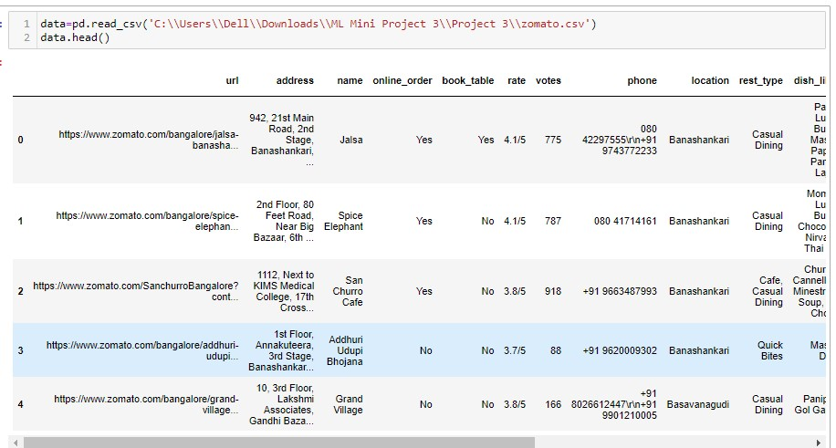

A.Step 2: Read the data, and convert the data types.

Code:

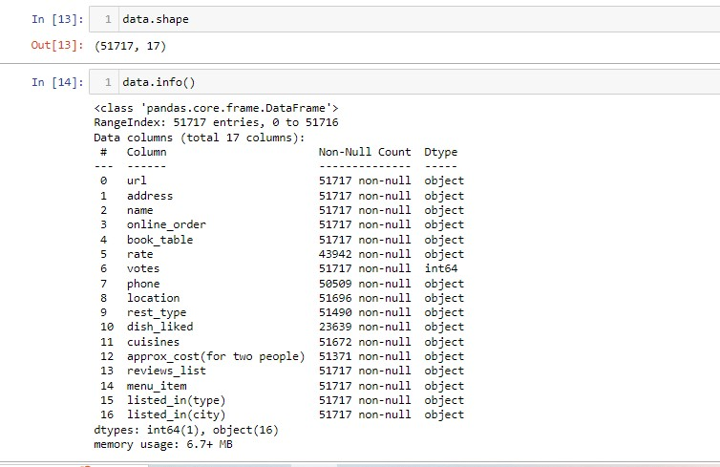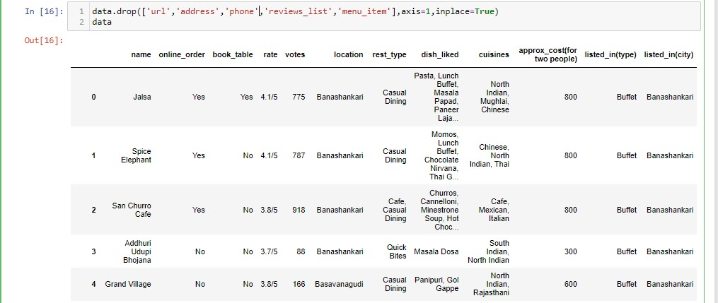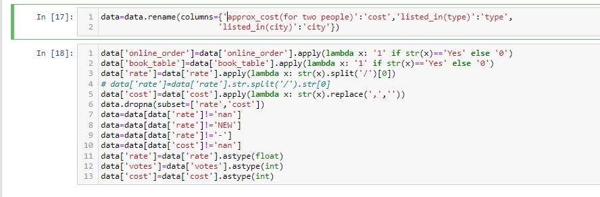

Step 3: Perform the described method for the data, Try to find any essential points from the described analysis. And check the missing values and Duplicate records. Impute the missing values in the best way possible.

Code:

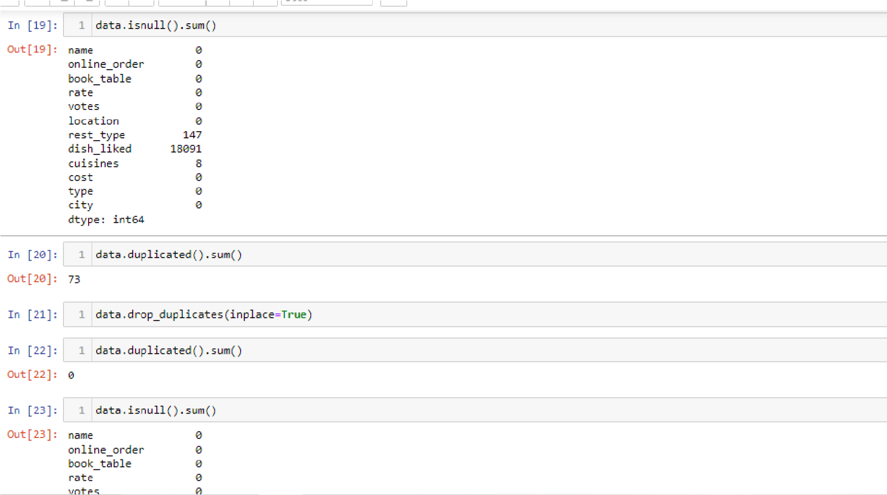

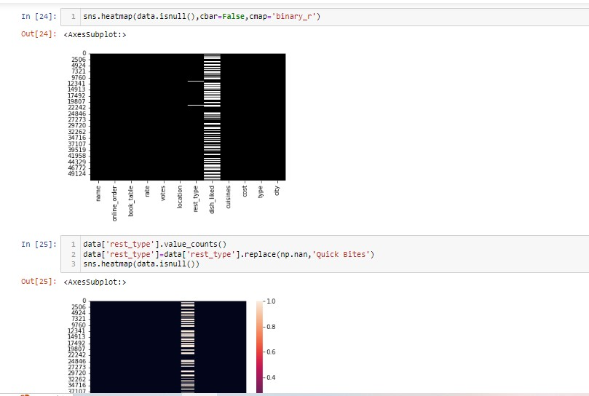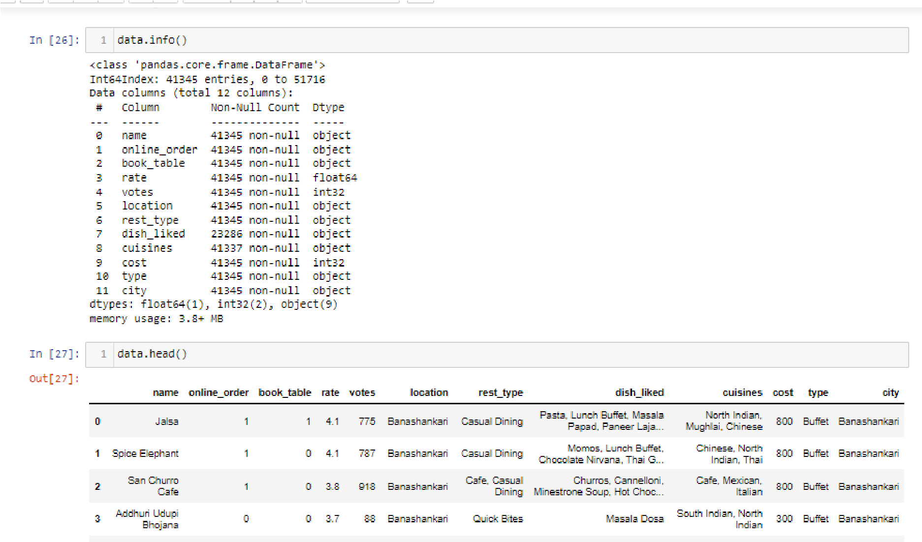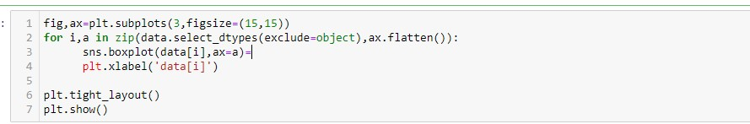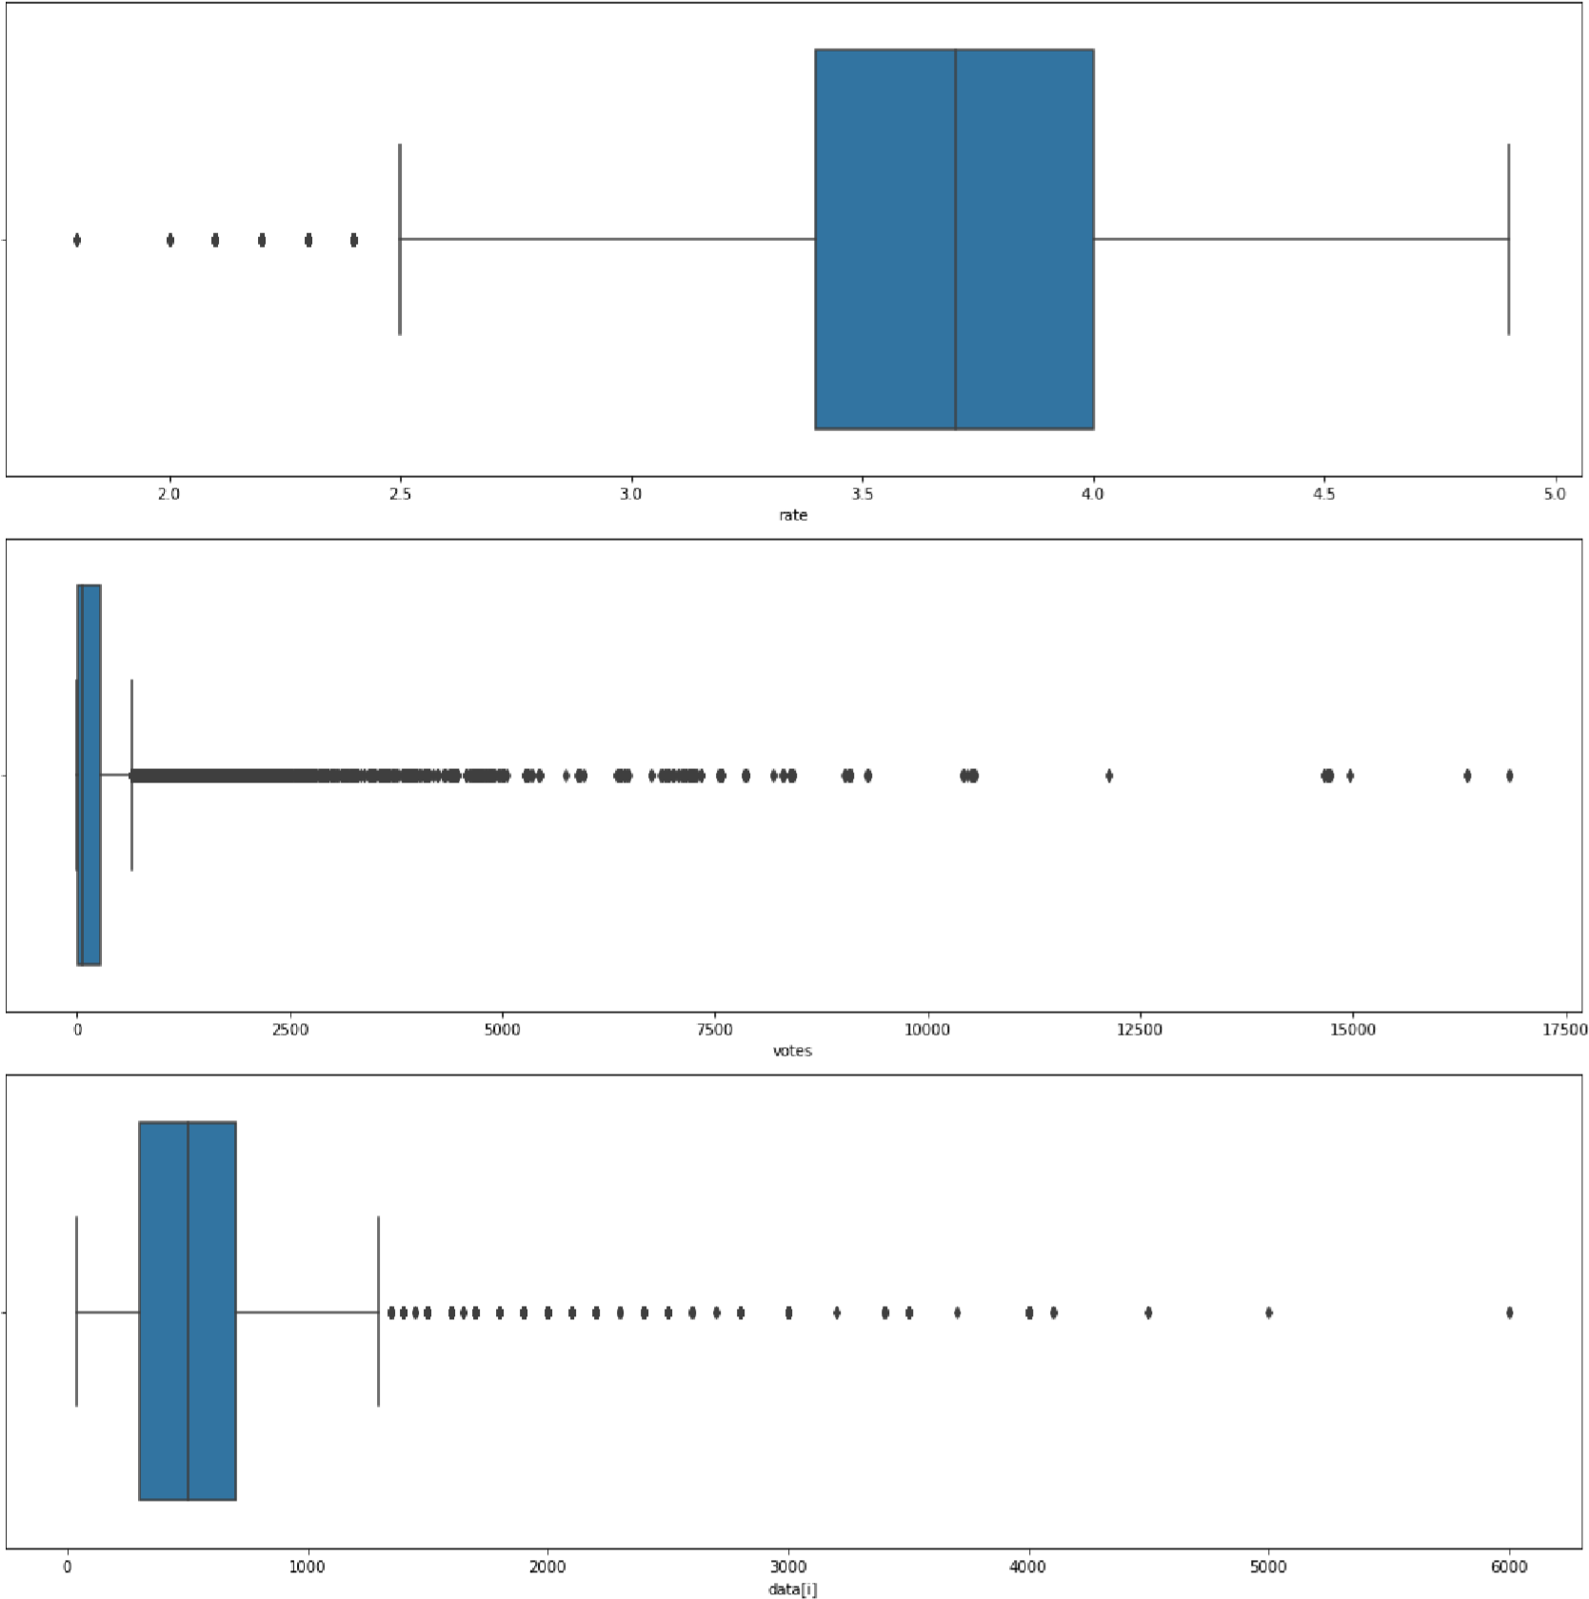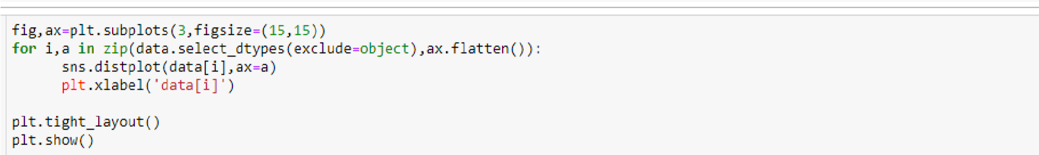

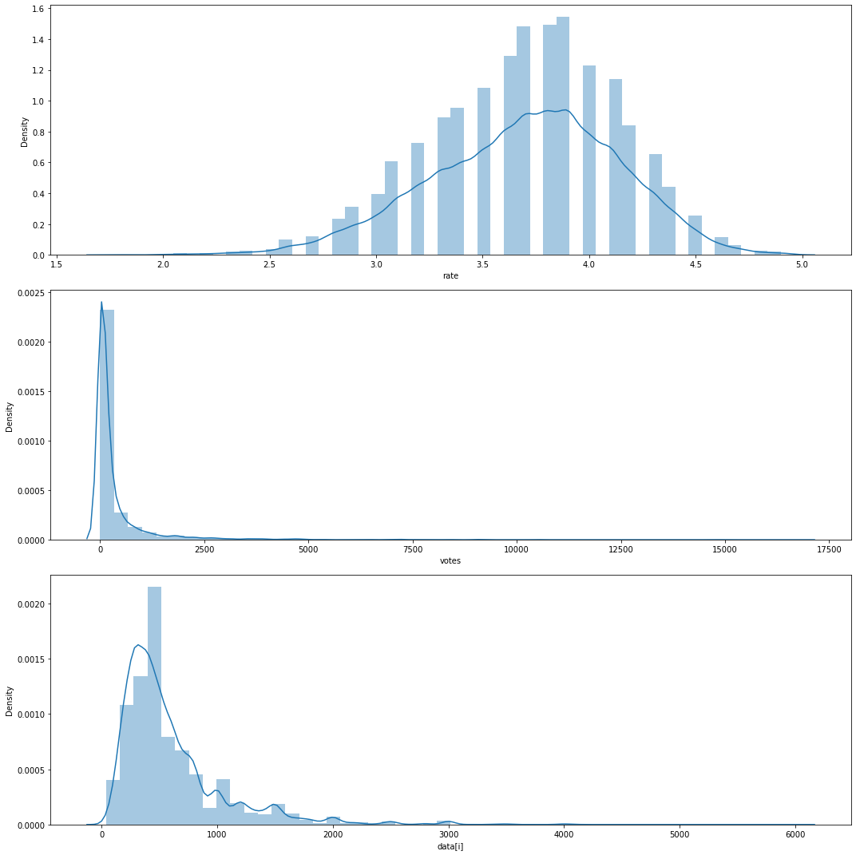

Step 4: Once the basic preprocessing is done like converting the data types, missing value imputation, and duplicate rows. perform the EDA(Exploratory Data Analysis) on the data to find the various factors that will help to understand the cost per two persons.

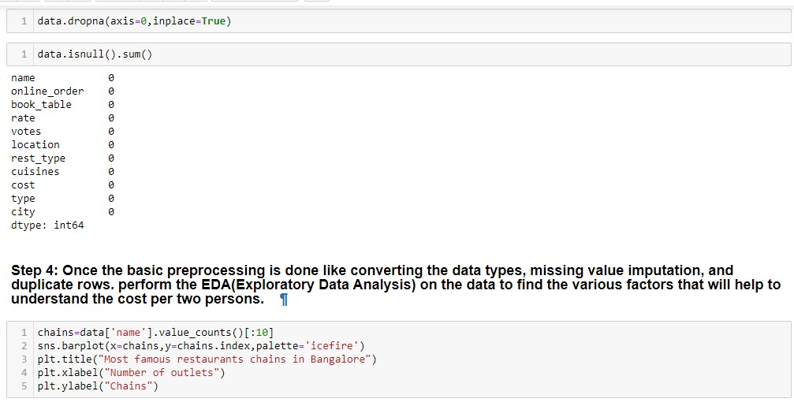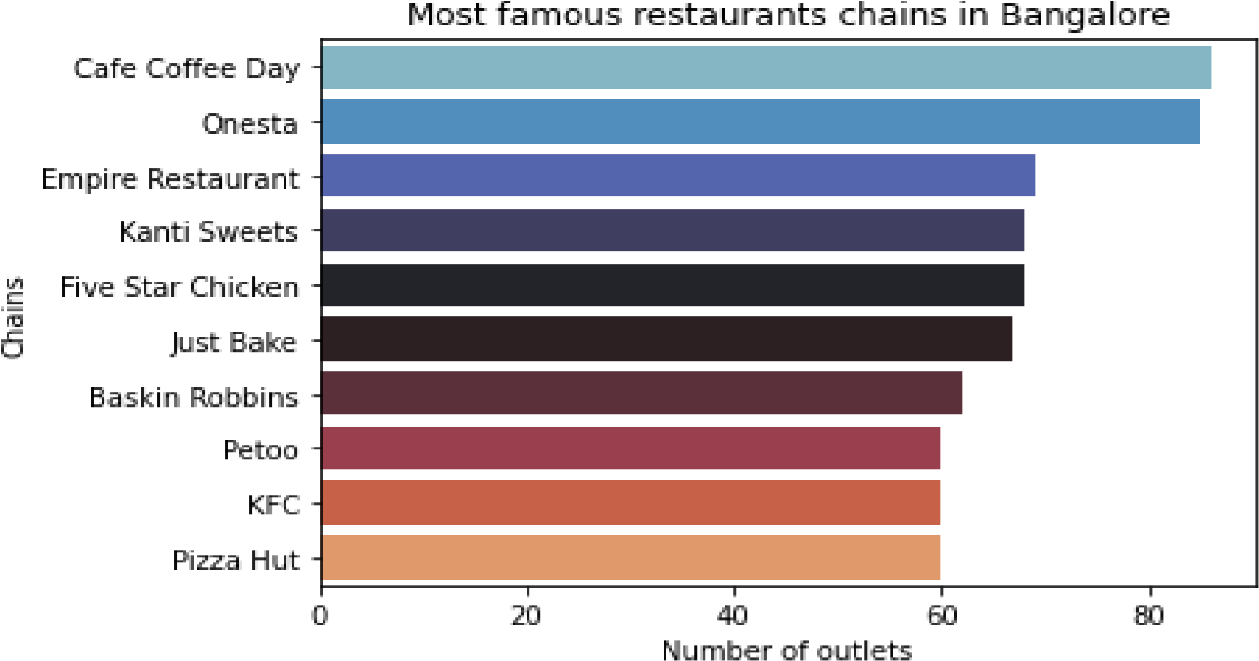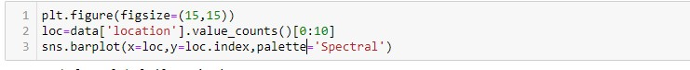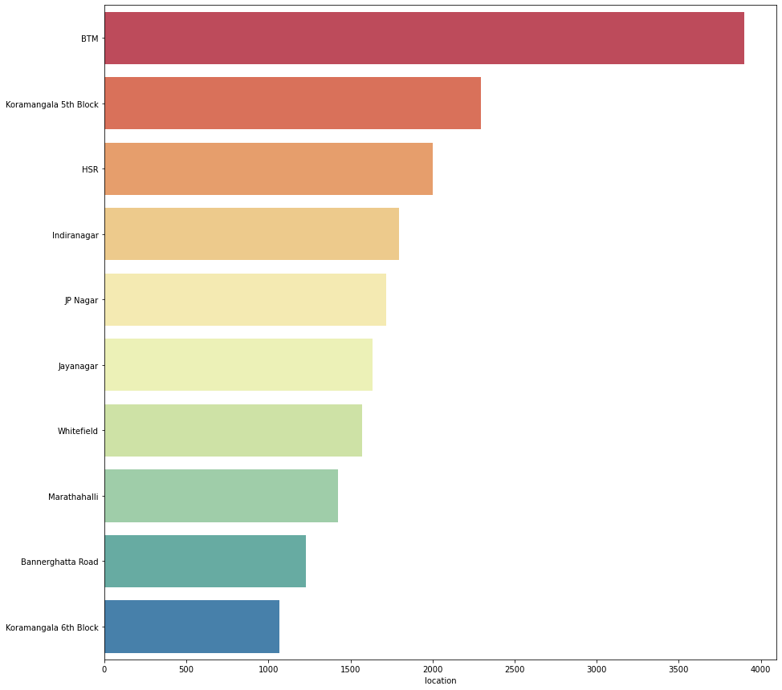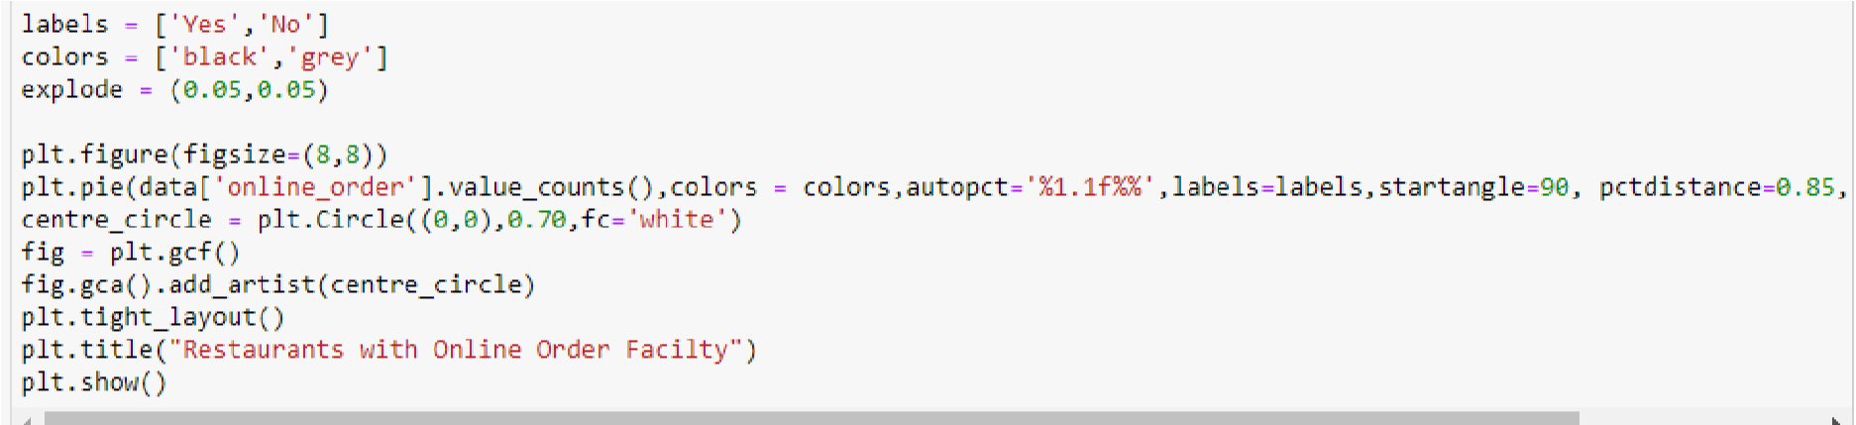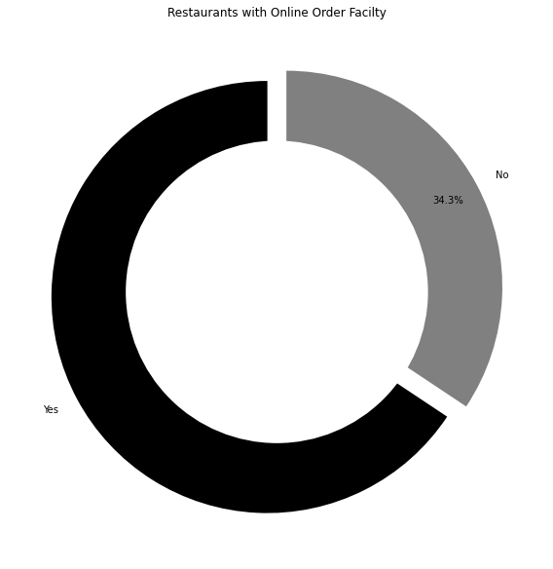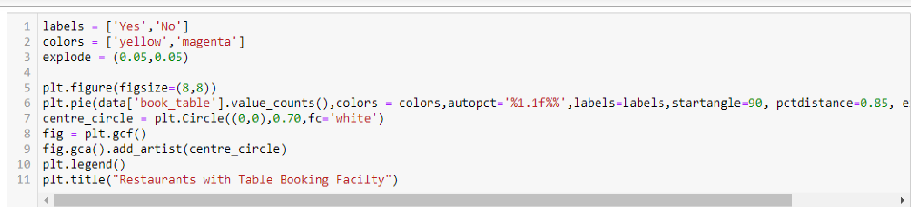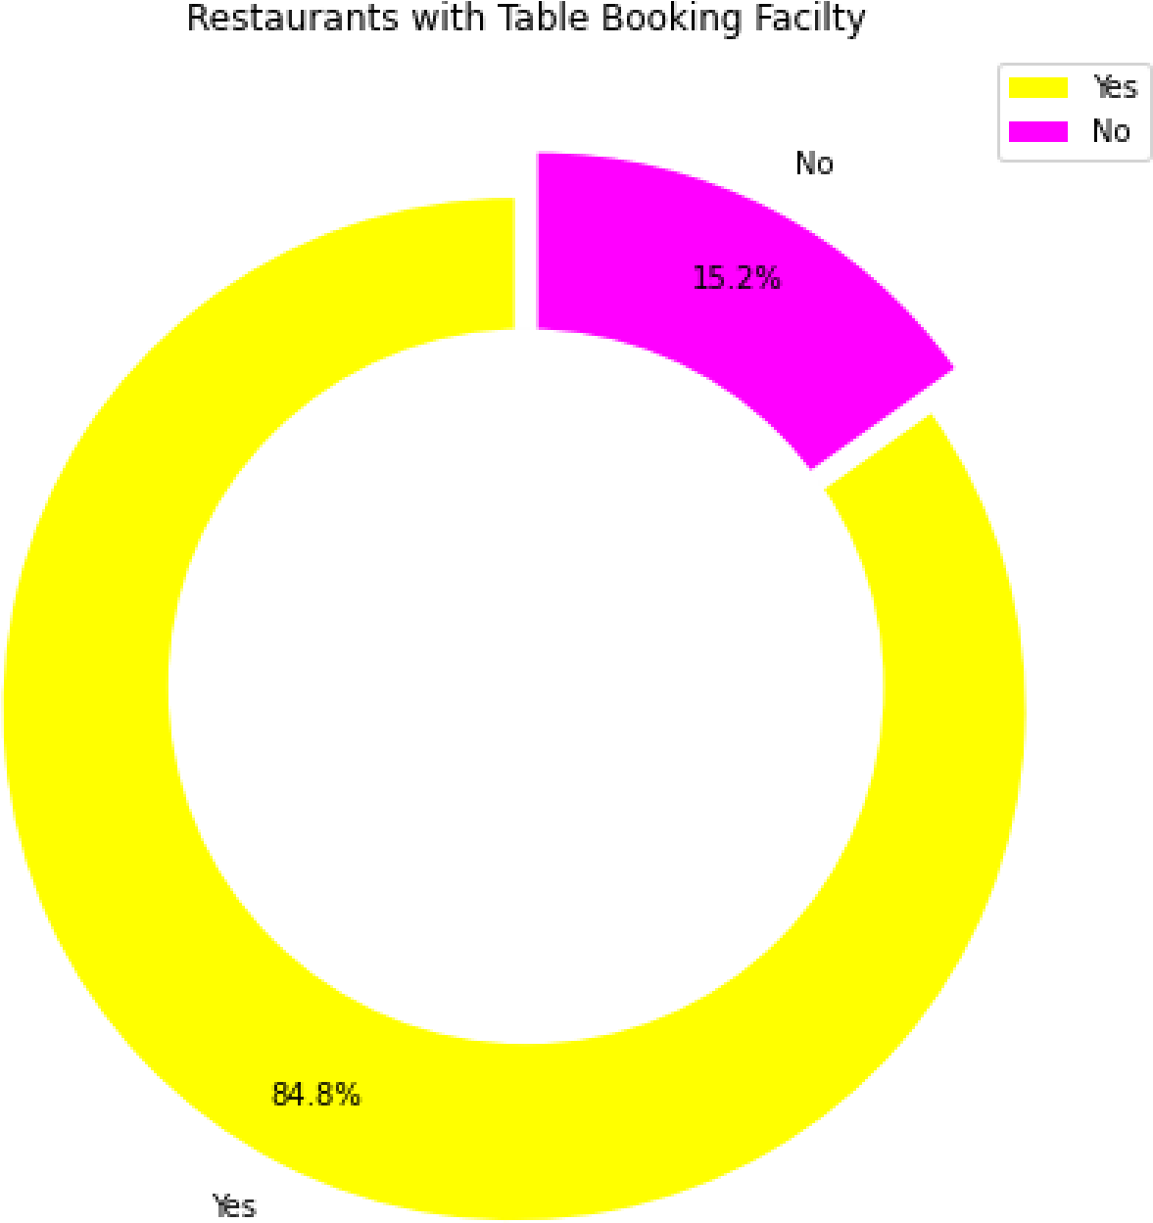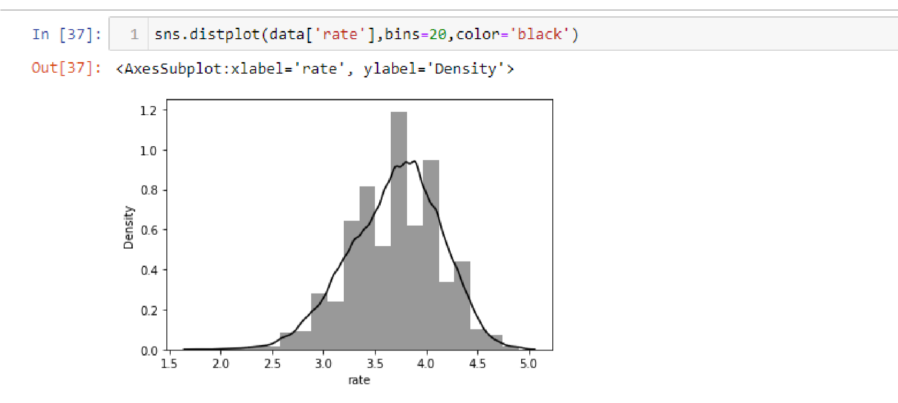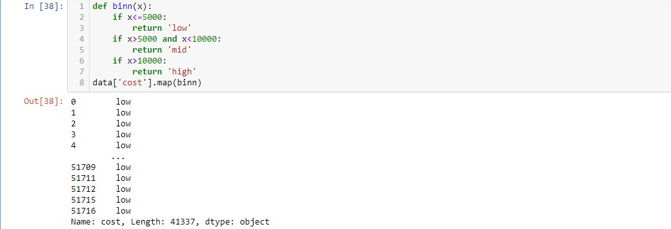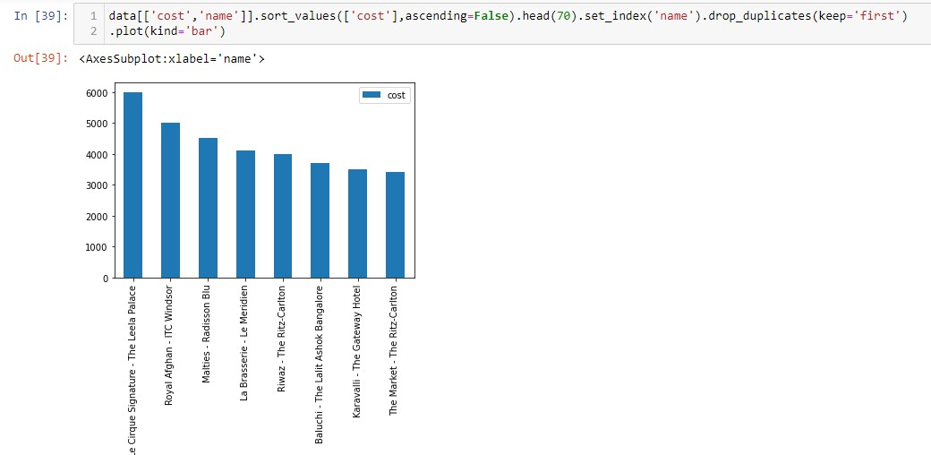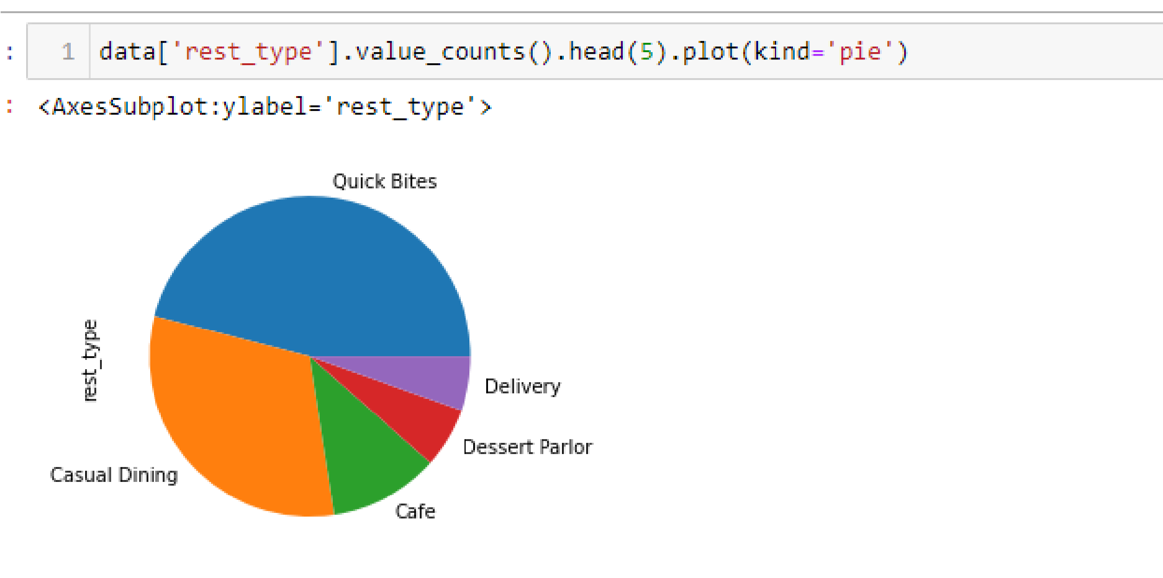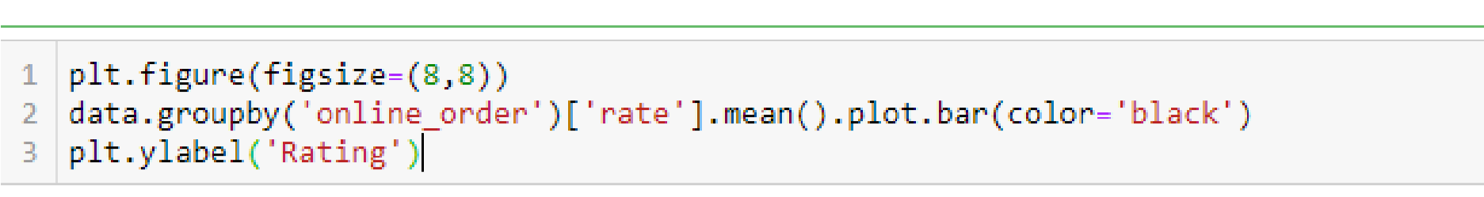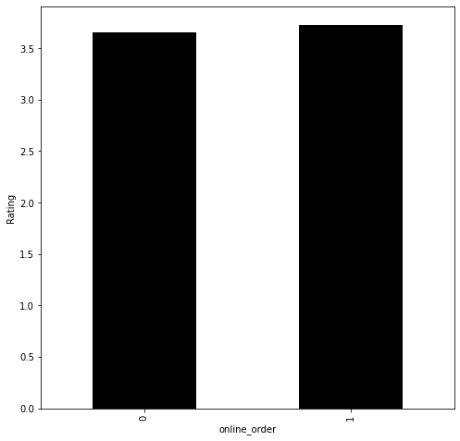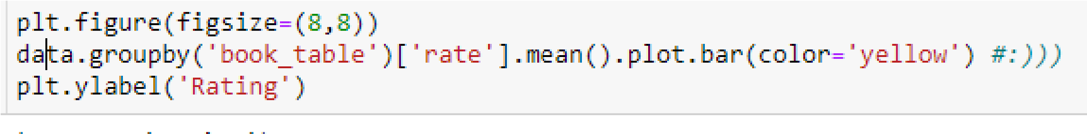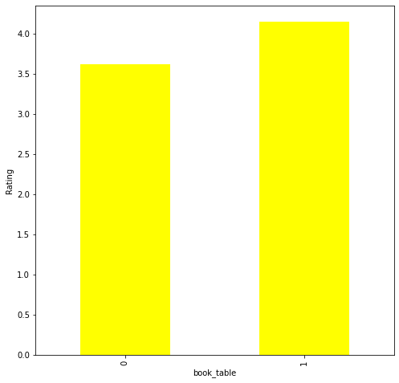

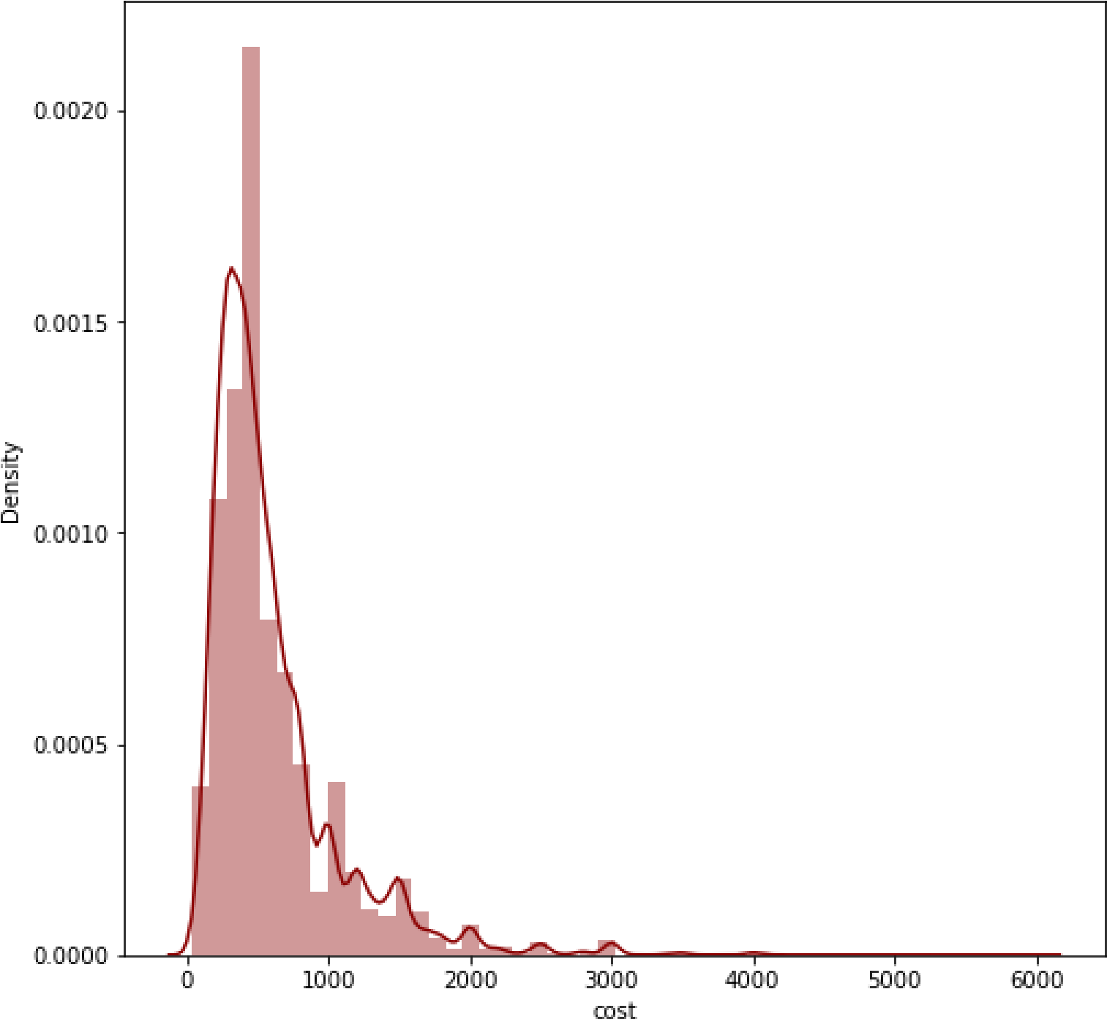

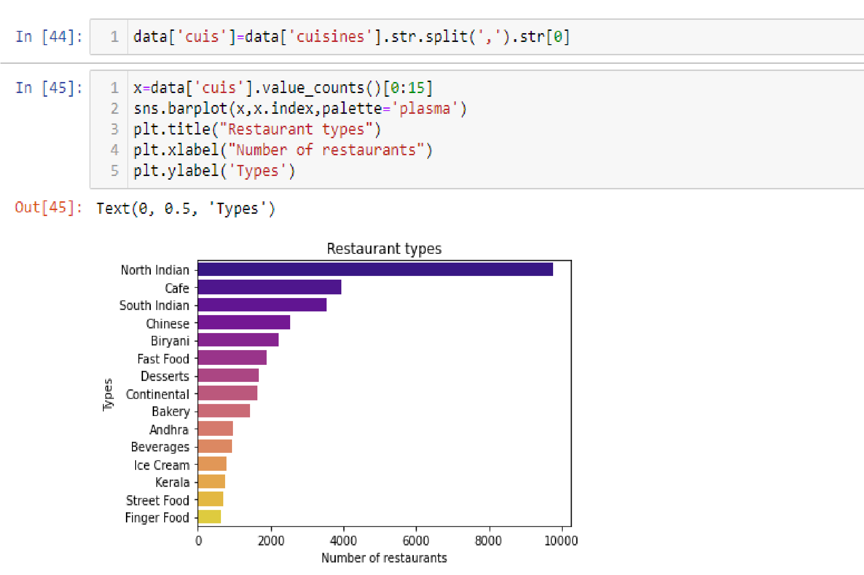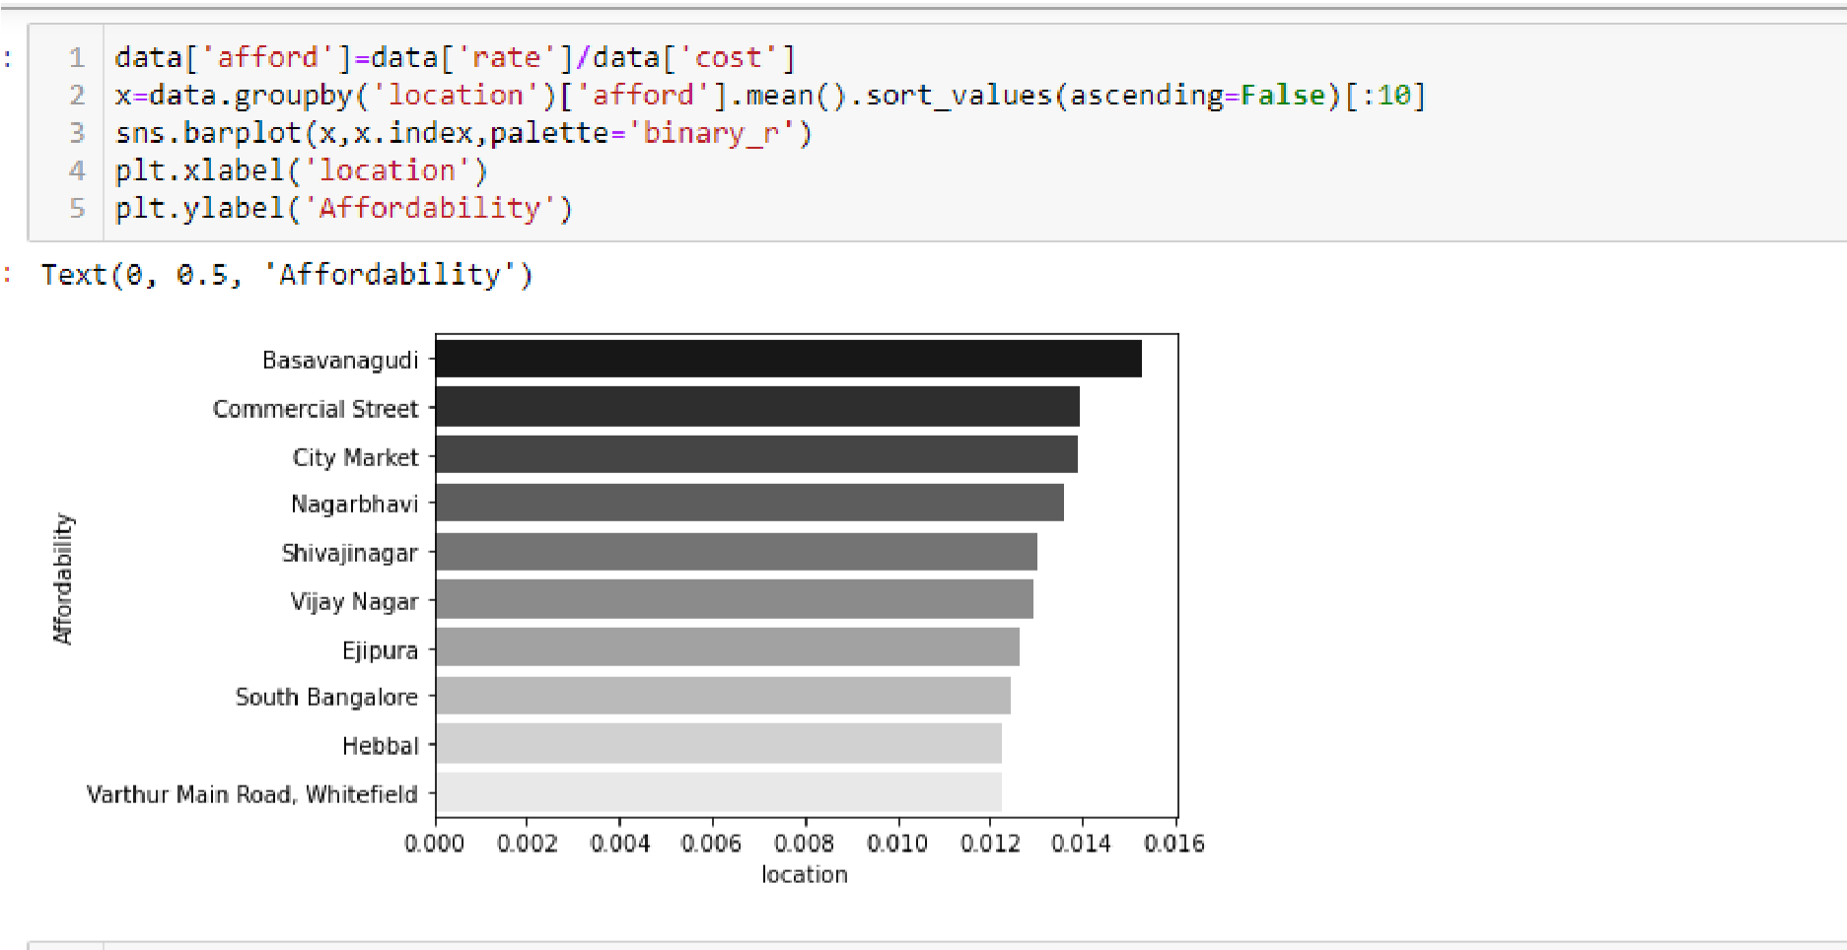

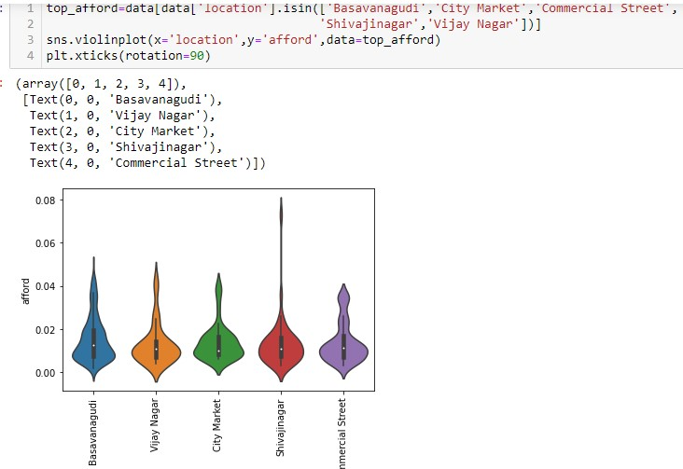

Step 5: Make a copy of the data set and Perform the preprocessing that require for the model.

Code:

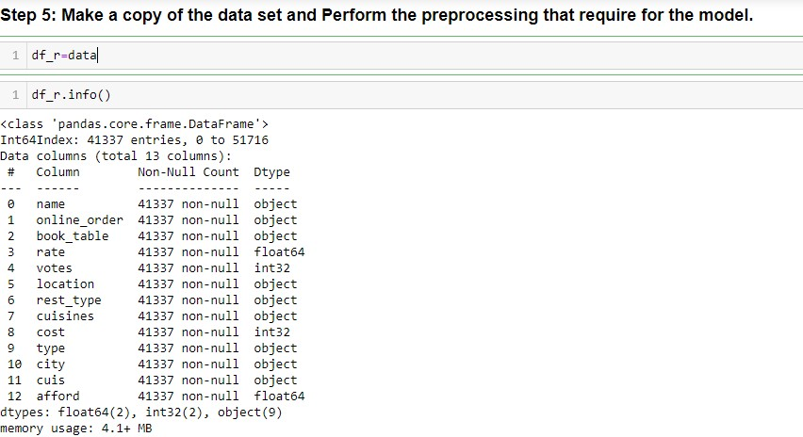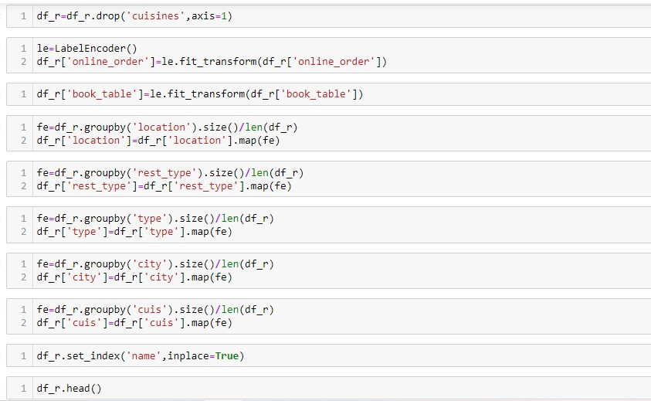

Step 6: Perform statistical hypothesis testing on features to get an idea of whether features are impacting the target variables Code:

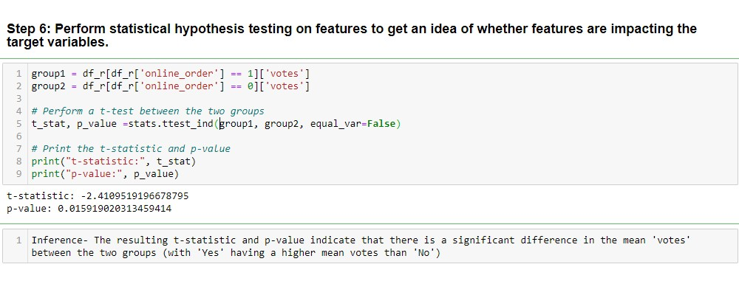

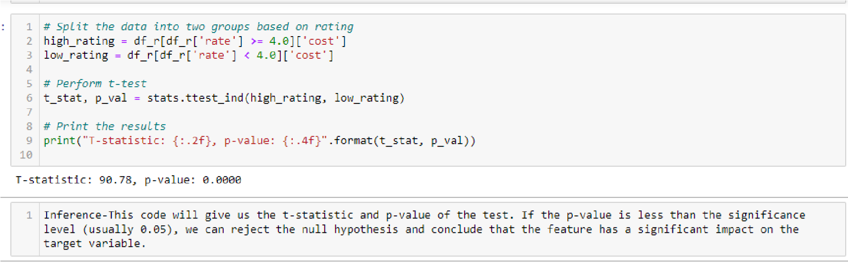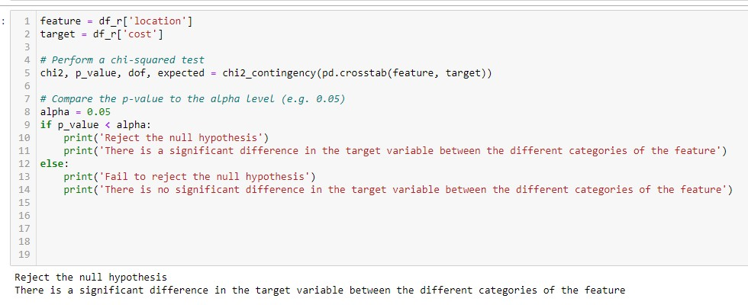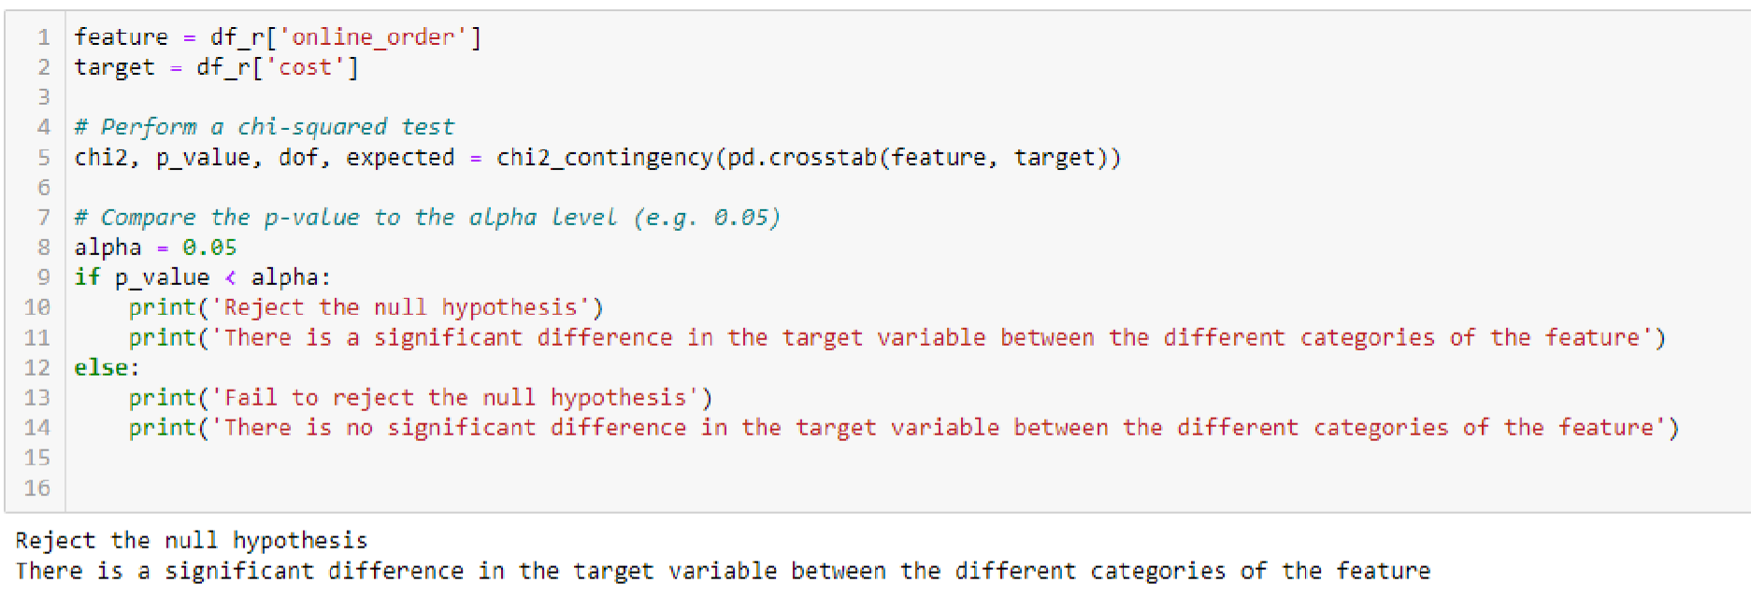

Step 7: Split the dataset into train and test data sets and Perform the scaling on both sets if necessary.

Code:

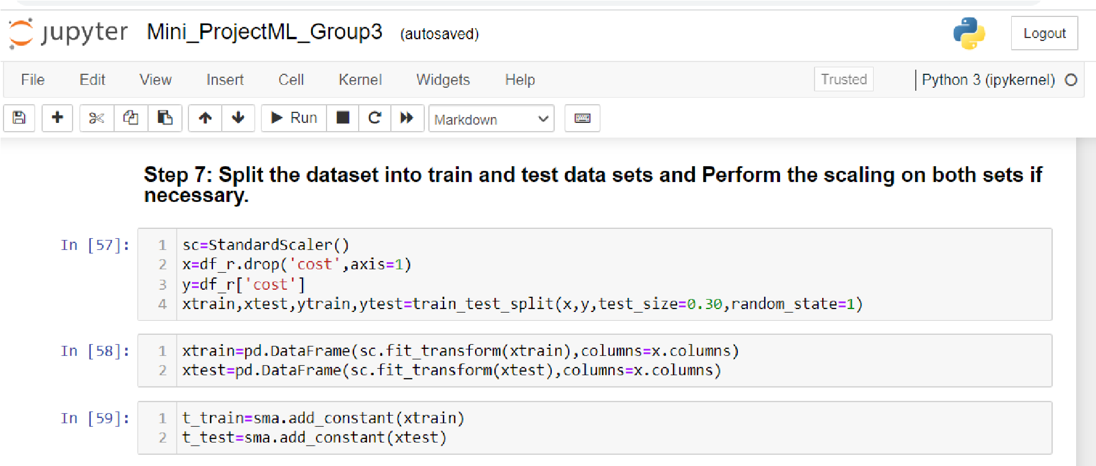

Step 8: Build the base model.

Code:

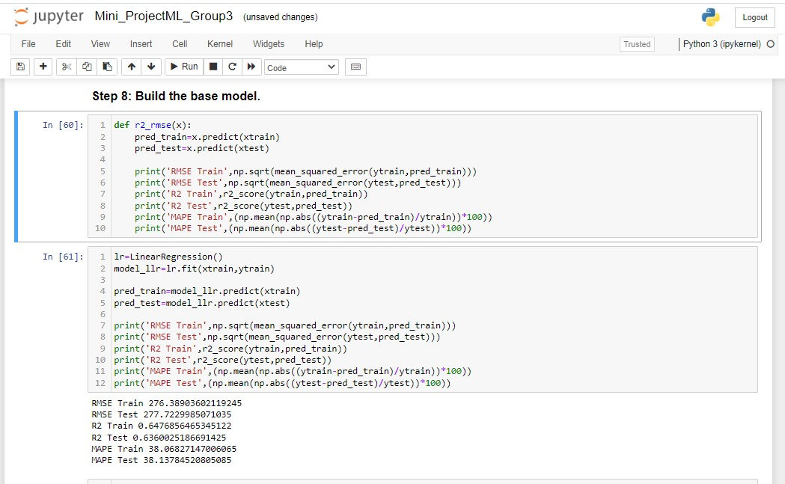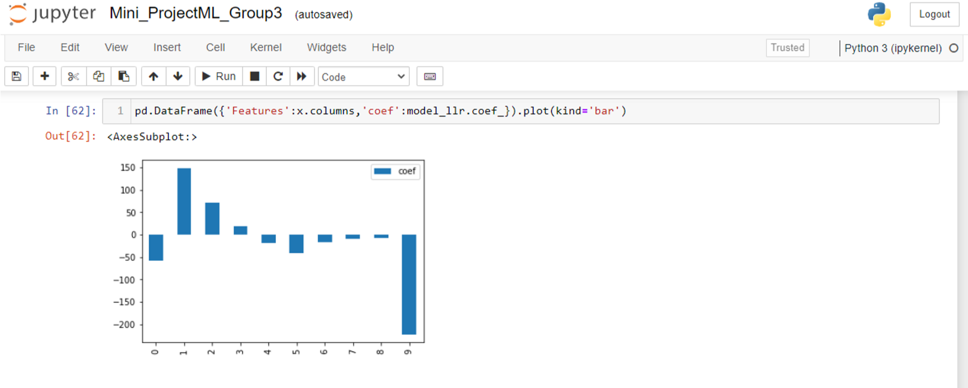

Step 9: Understand how the model is performing, Perform feature engineering again if needed. Do feature selection. Try with various models like a parametric and nonparametric models. Once you choose the final model, rebuild the model with best parameters.

Code:

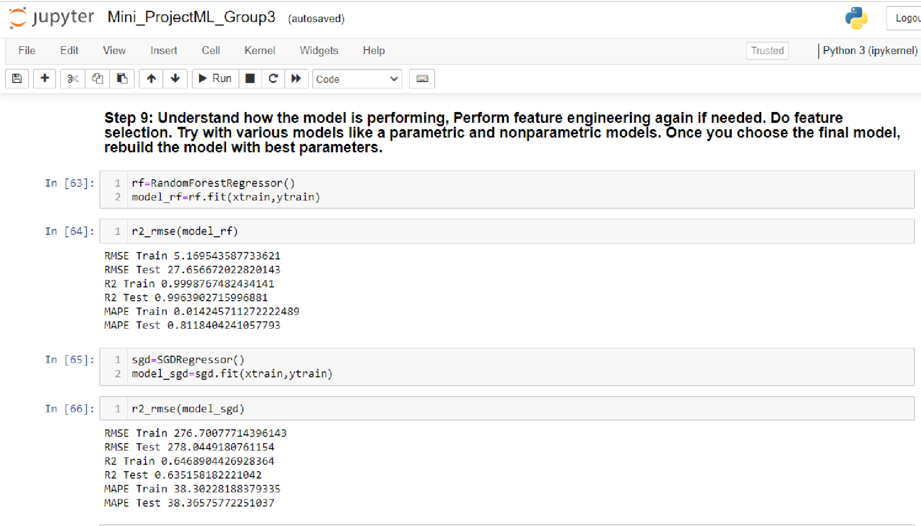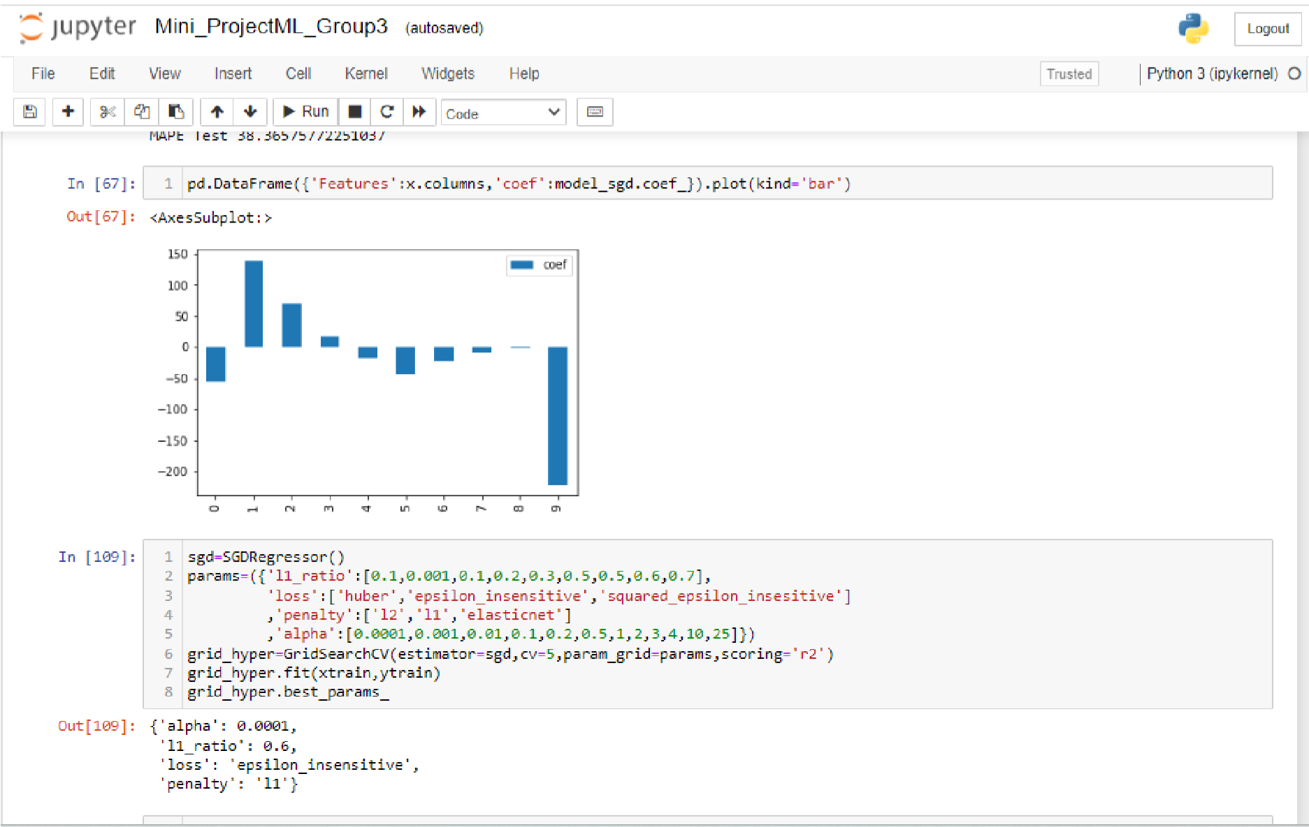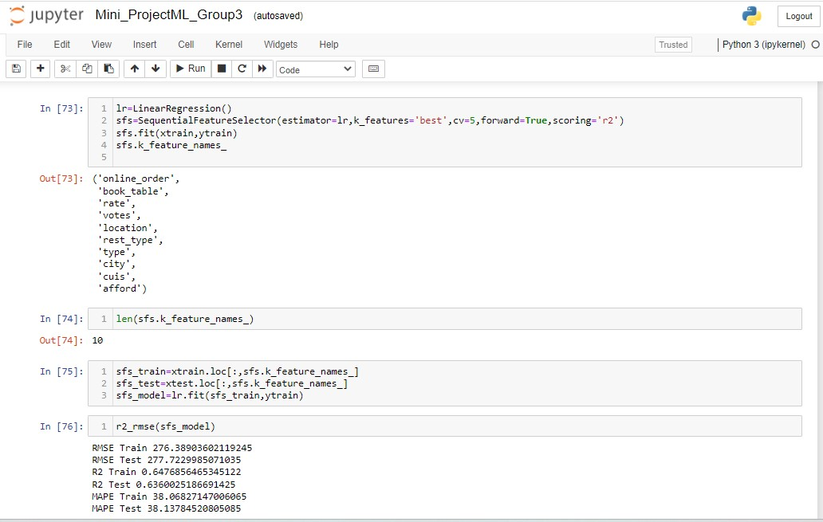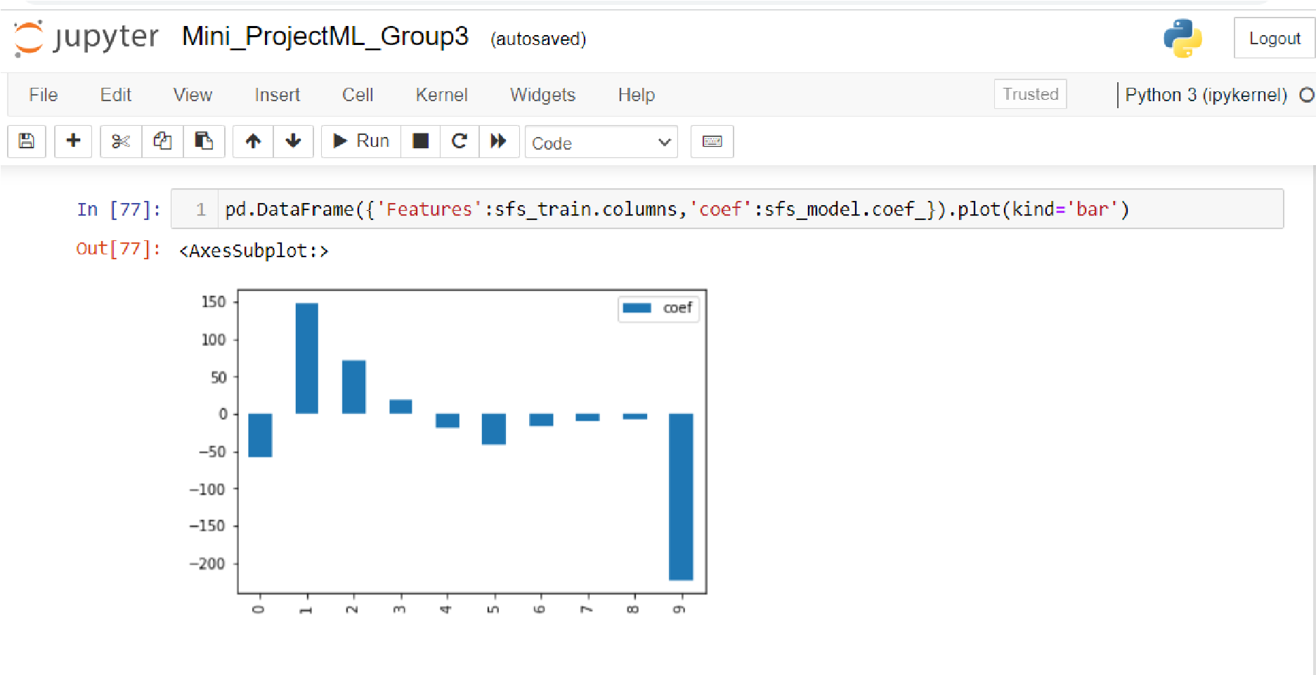

Inference:

PGPDSE – Location - Batch

Step 10: Based on your understanding of the model and EDA analysis, Explain the business understanding.

Code:

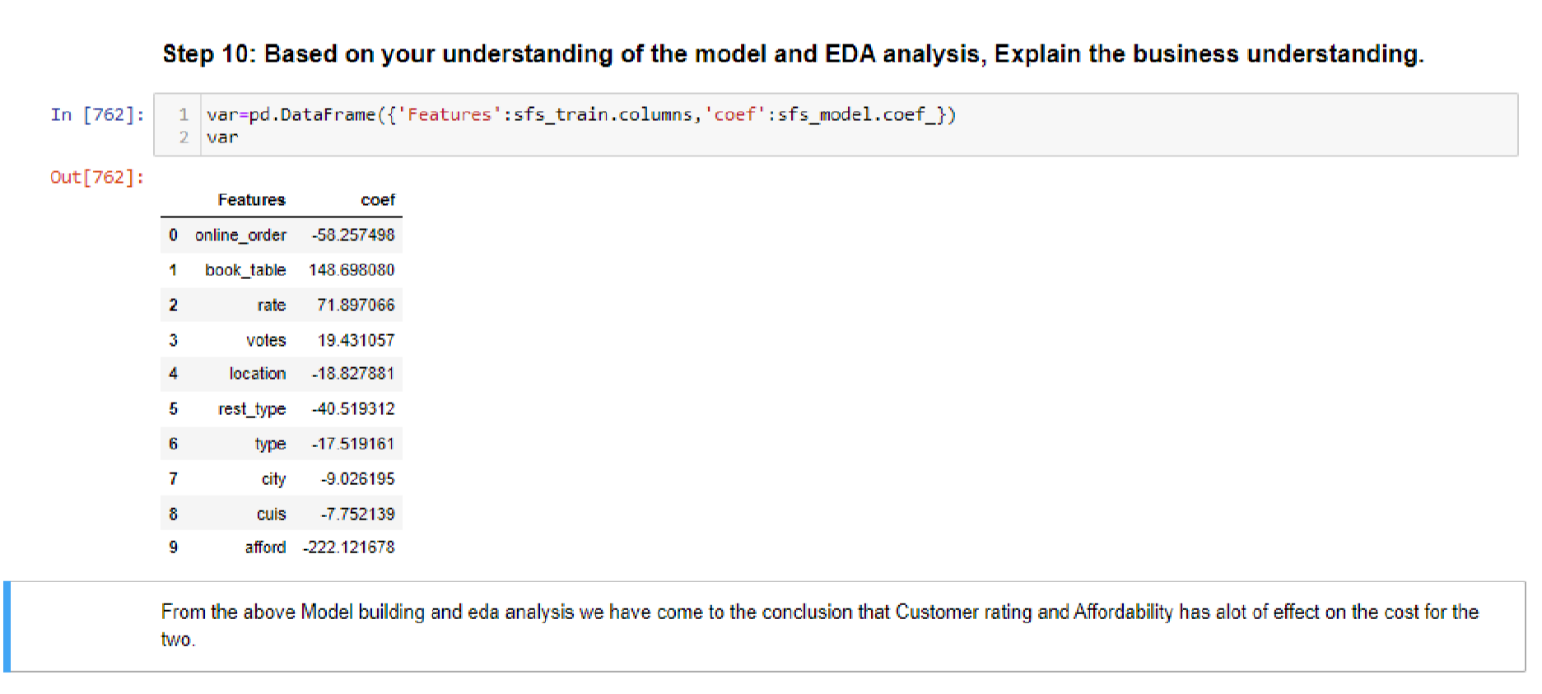

## Section B:

**Problem Statement:**

The model that you built in the above case study has gone to deployment and Zomato has been impressed with your data analysis and Zomoto has been believing that your analysis going to be impactful. Now Zomato has been observing the orders happening online and offline, Due to offline orders, Zomato is not able to attract customers with diverse items and offers, and the user subscription also getting low. so it has decided to give you the project on the same. Now the problem statement is that Zomato wants to know whether the customer would order the orders online or offline so that Zomato can take further strategies to improve the online order.

**Objective:**

The Aim is to classify the orders that have been ordered online and offline. And identify the patterns that lead to orders online orders as well as offline. Your model should be able to classify the classes effectively

## Questions:

Step 1: Understand the problem statement,Identify the metric for the problem.

Code:

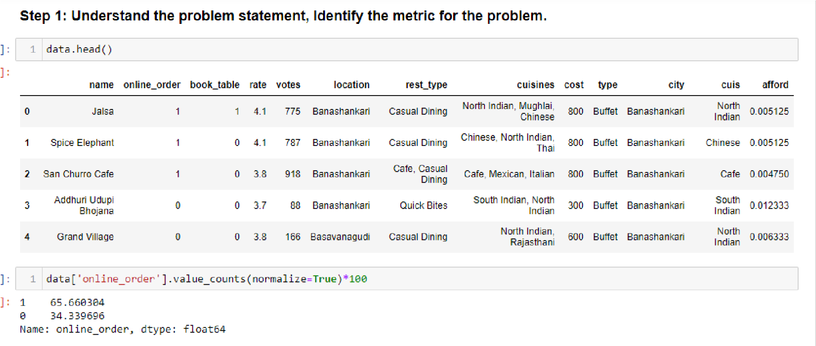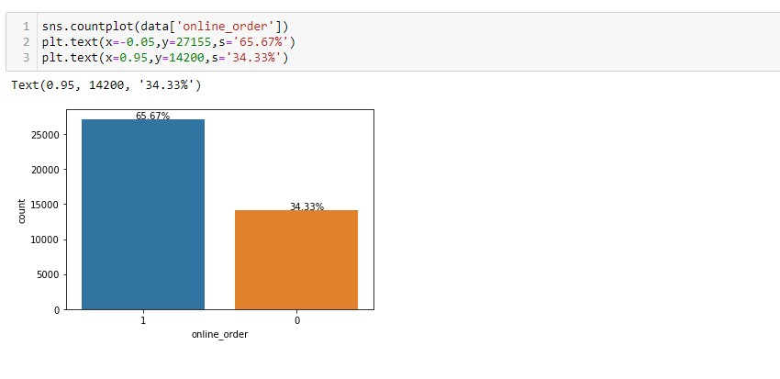

step 2: Use the data sets that have been cleaned data types and missing values in section A step 3.

Code:

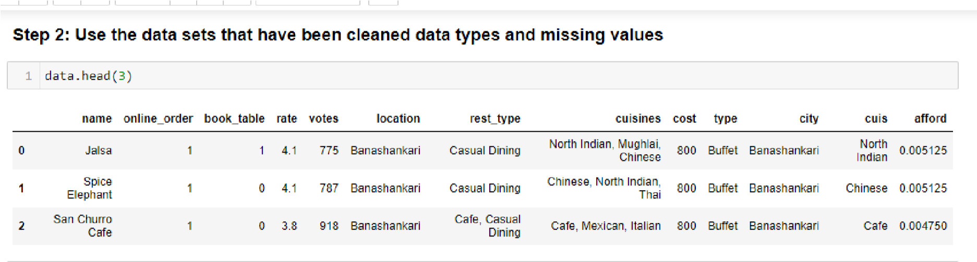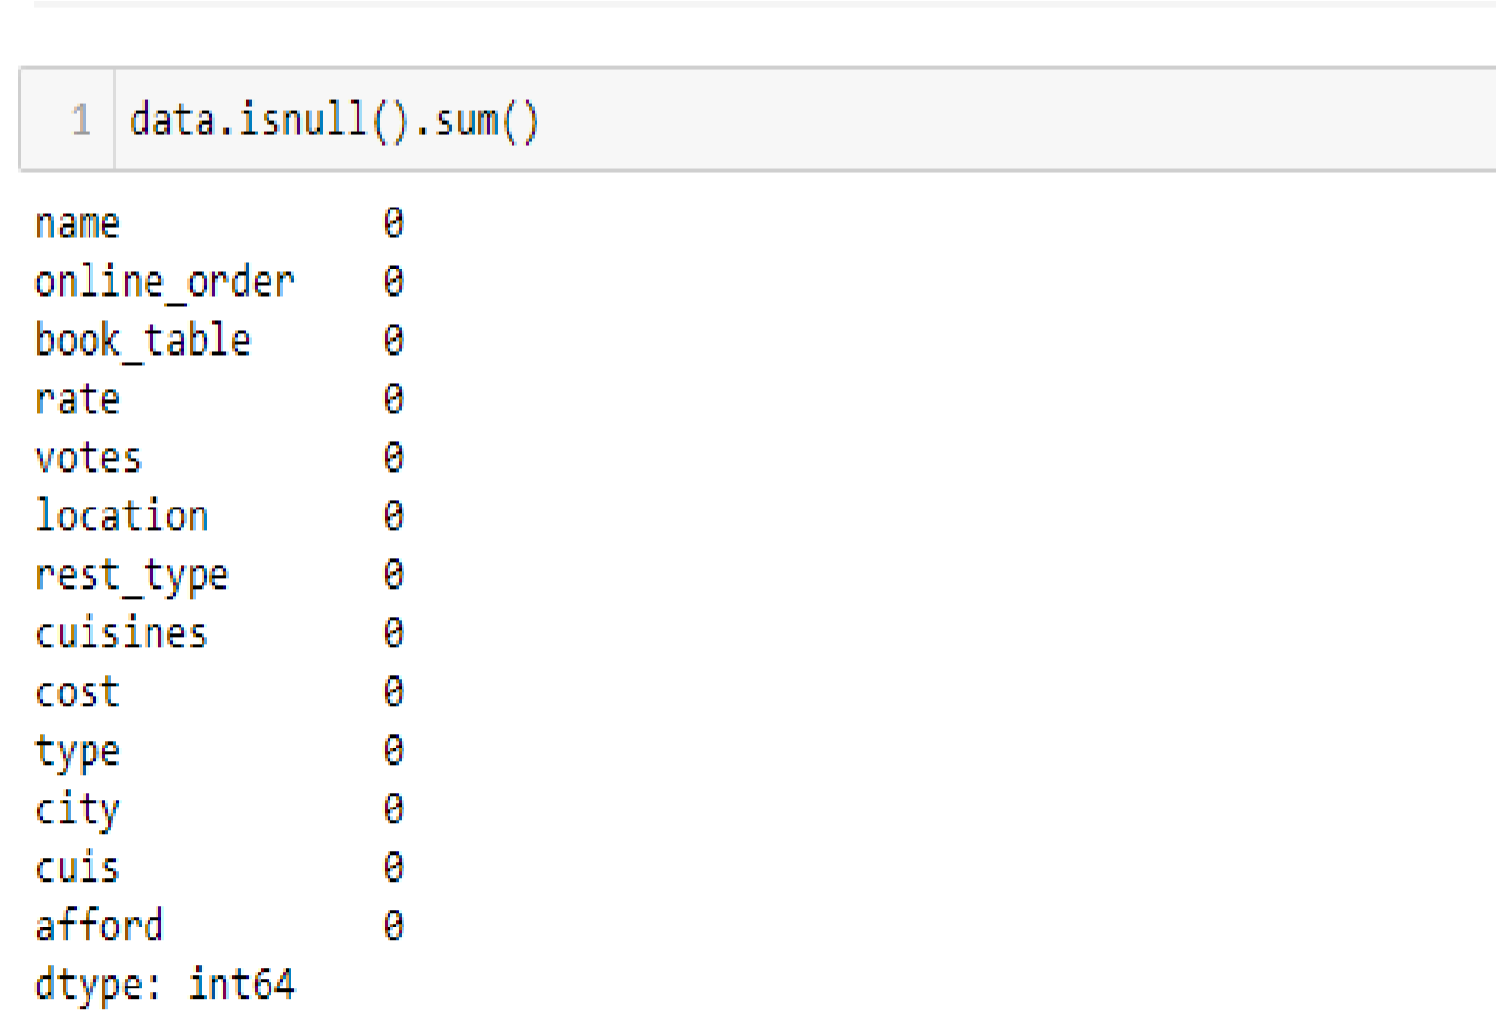

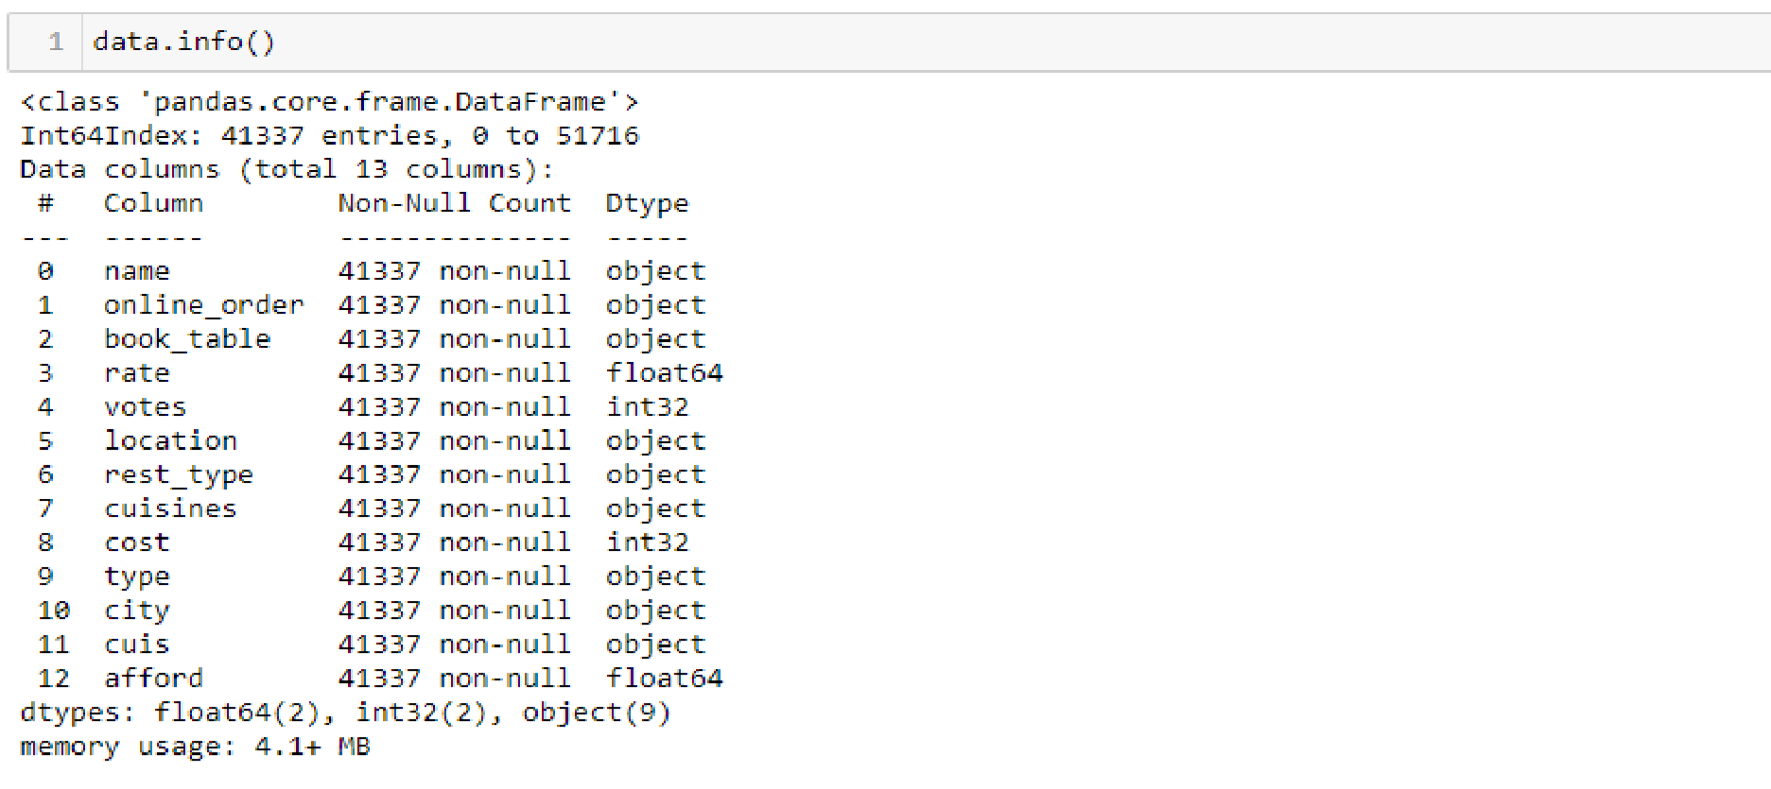

Step 3:

i) Explore the data and find the hidden patterns in the data that affect your objective(target variable)

Code:

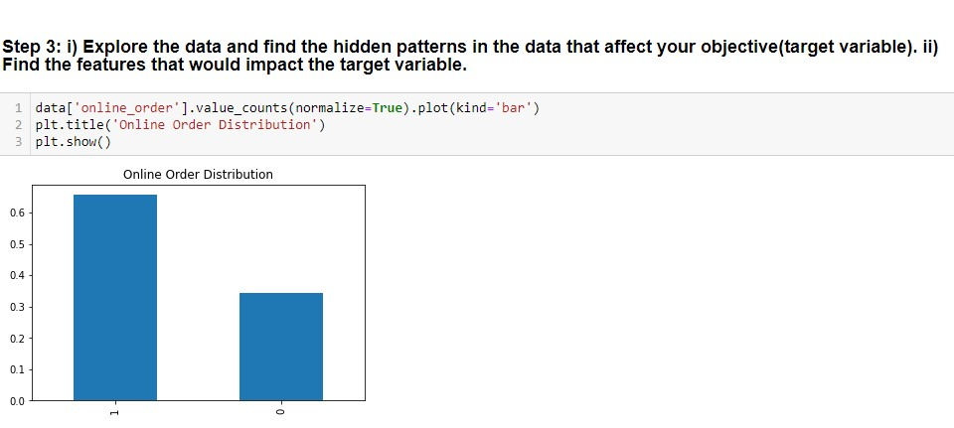

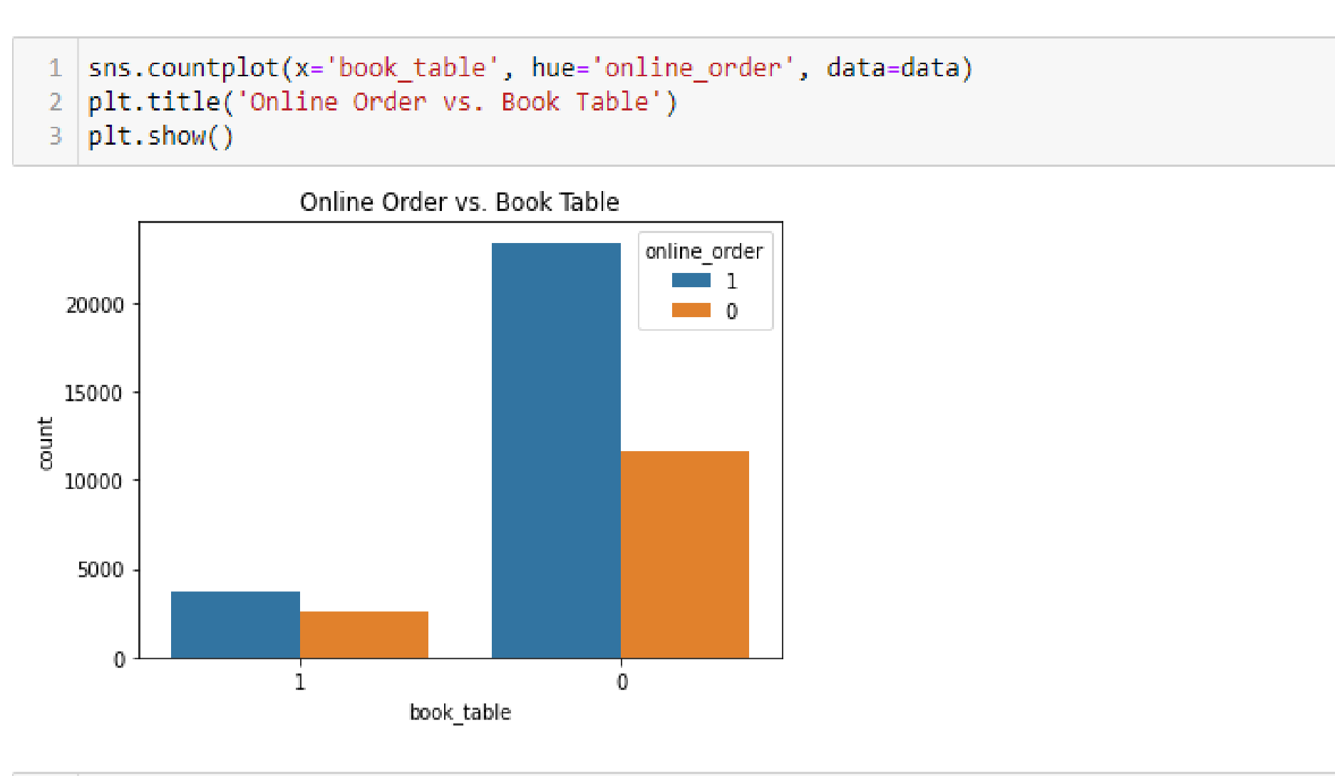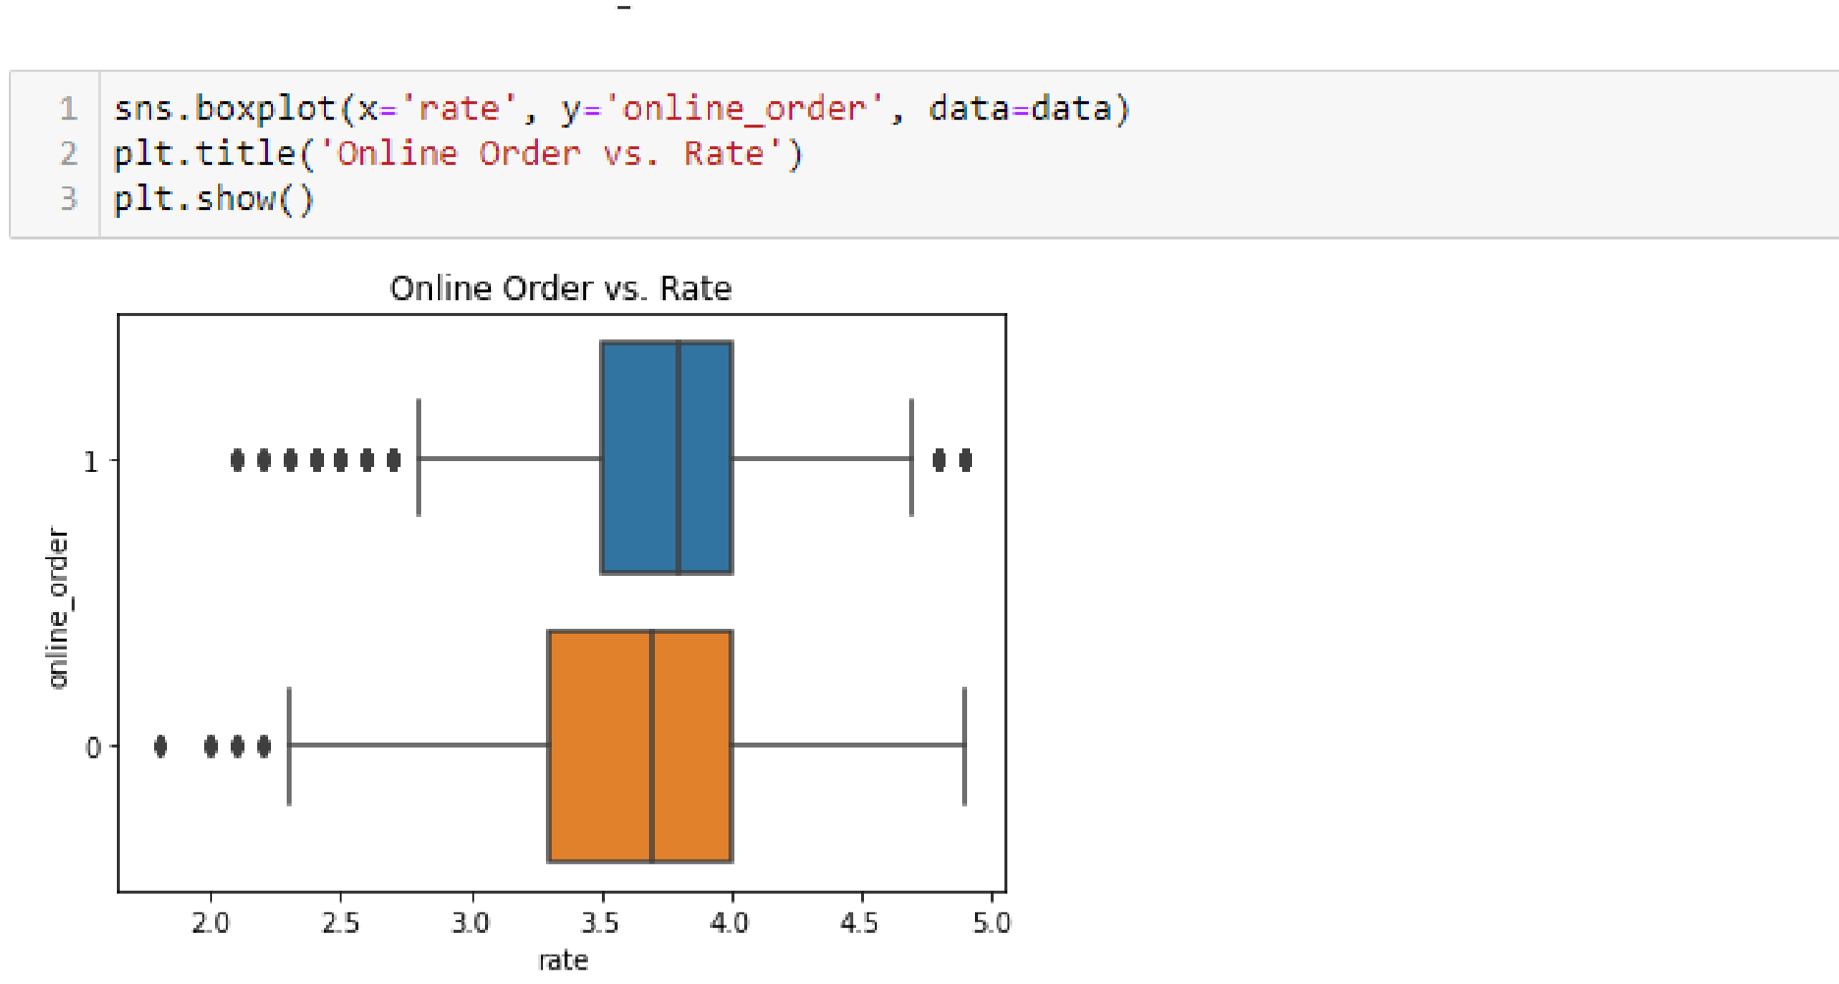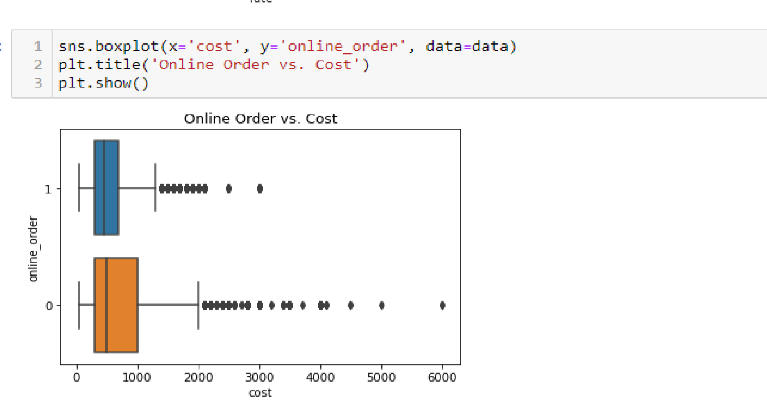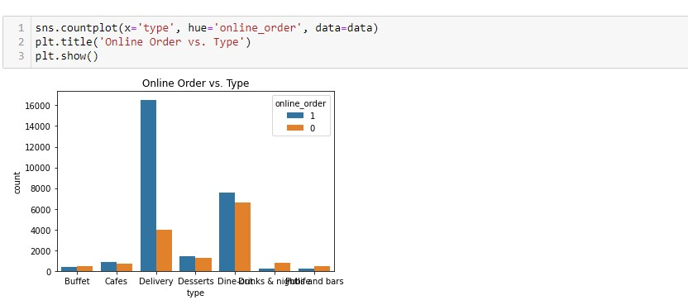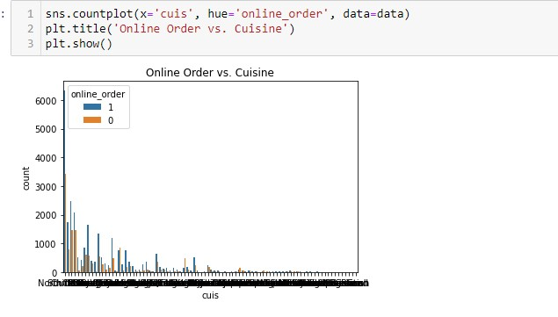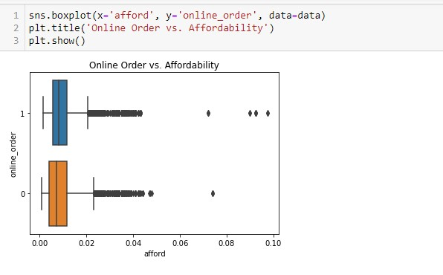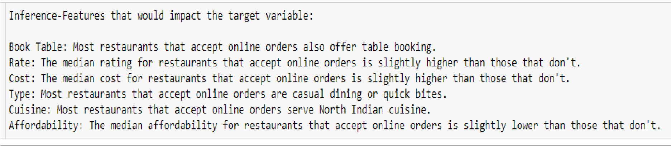

step 4: Do the preprocessing in a way that impacts the models that you going to build.

Note: If you feel the few preprocessing steps that you did in section 1, feel free to use those steps.

Code:

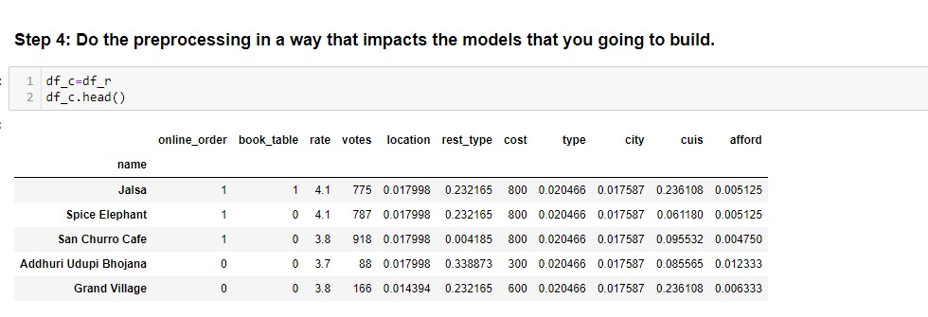

Step 5: Prove statistically about step 2 point ii

Code:

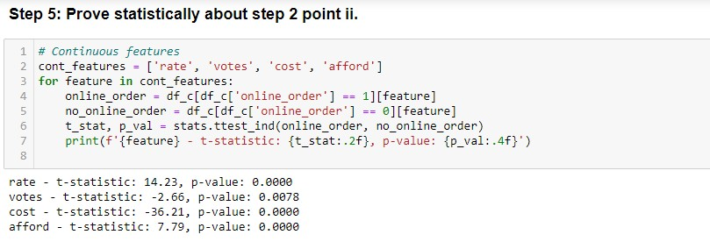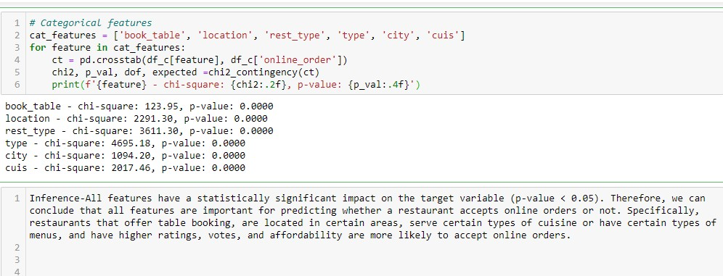

Step 6: Split the data into train and test sets.

Code:

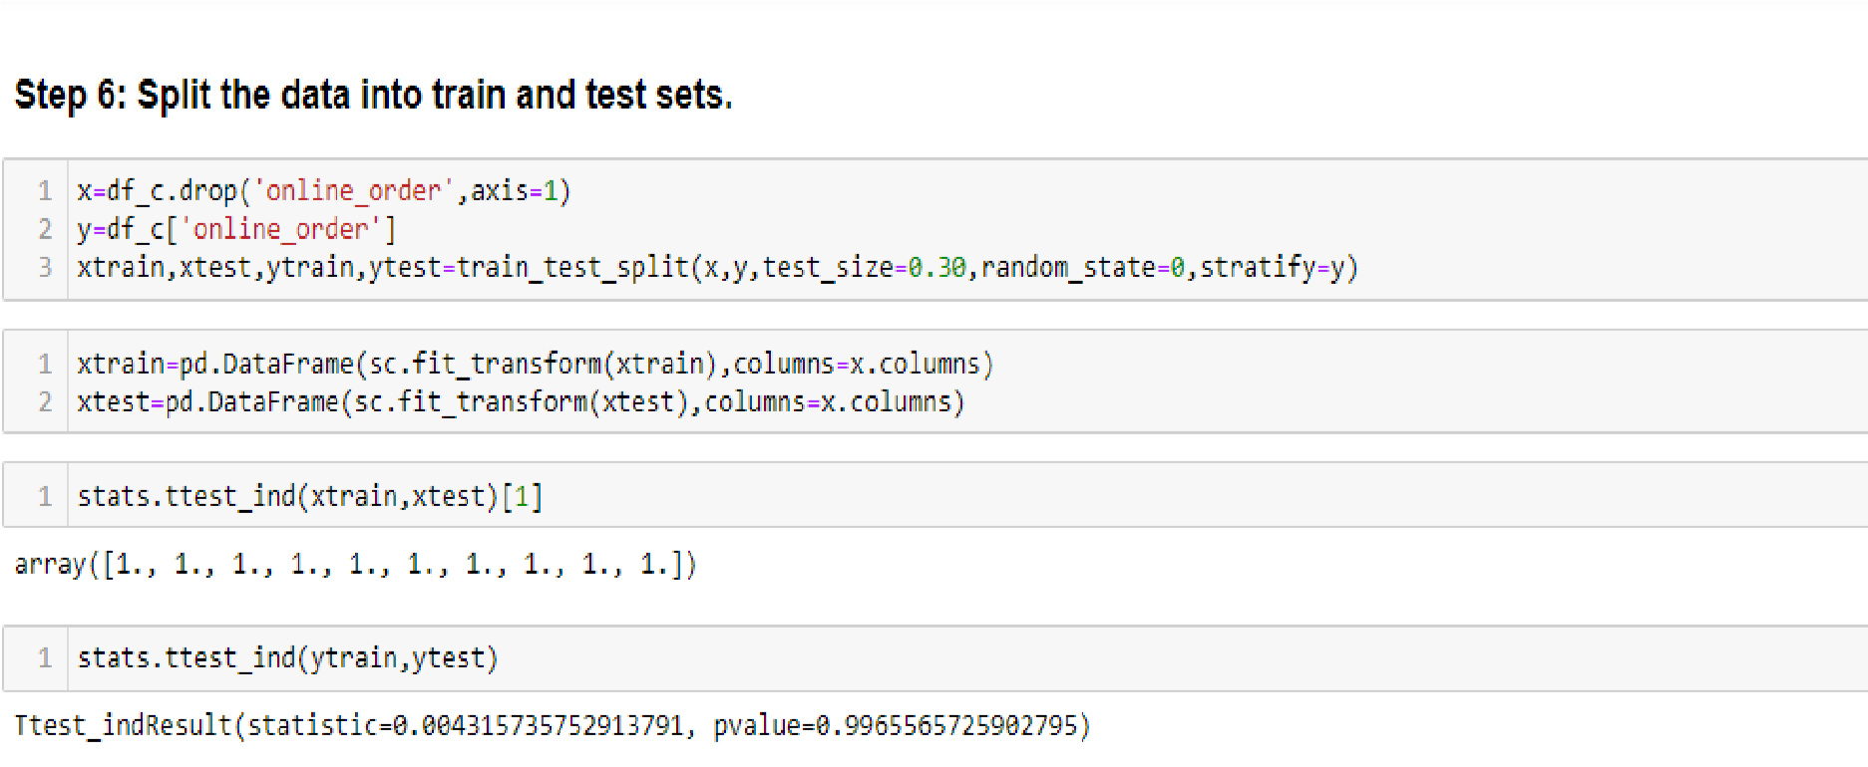

Step 7: Build the base model and Identify your metric based on the problem

Code:

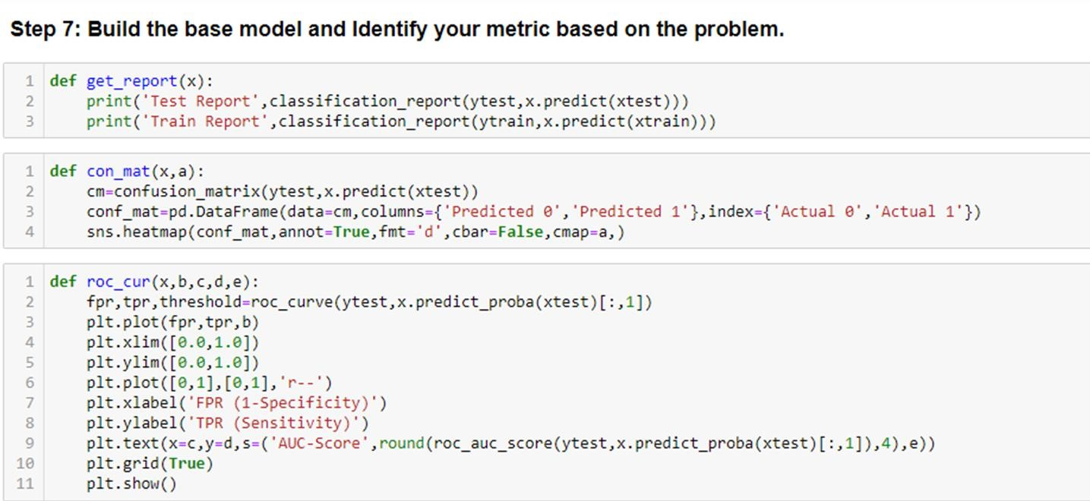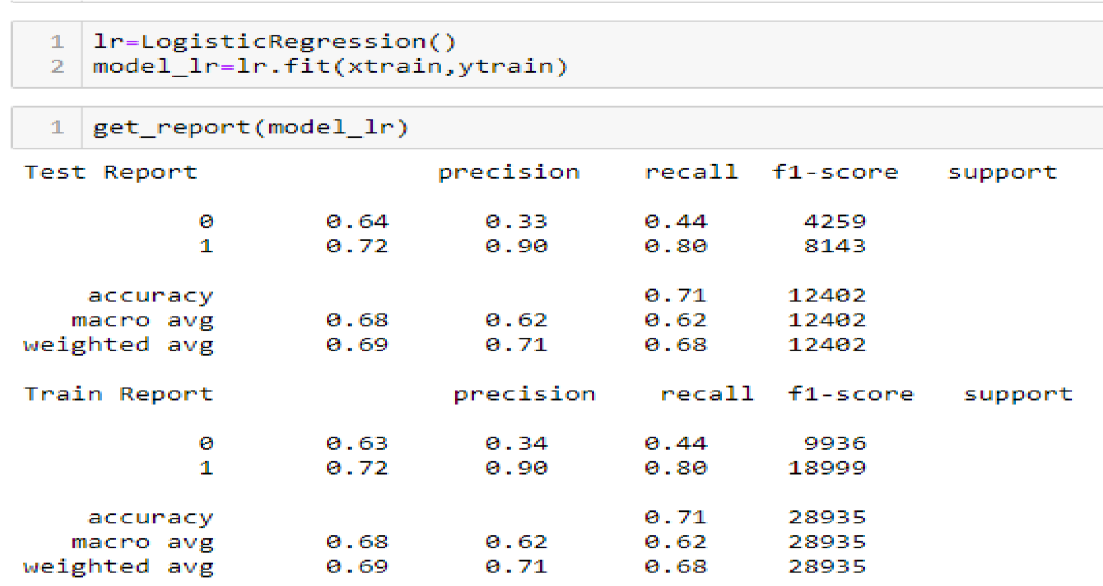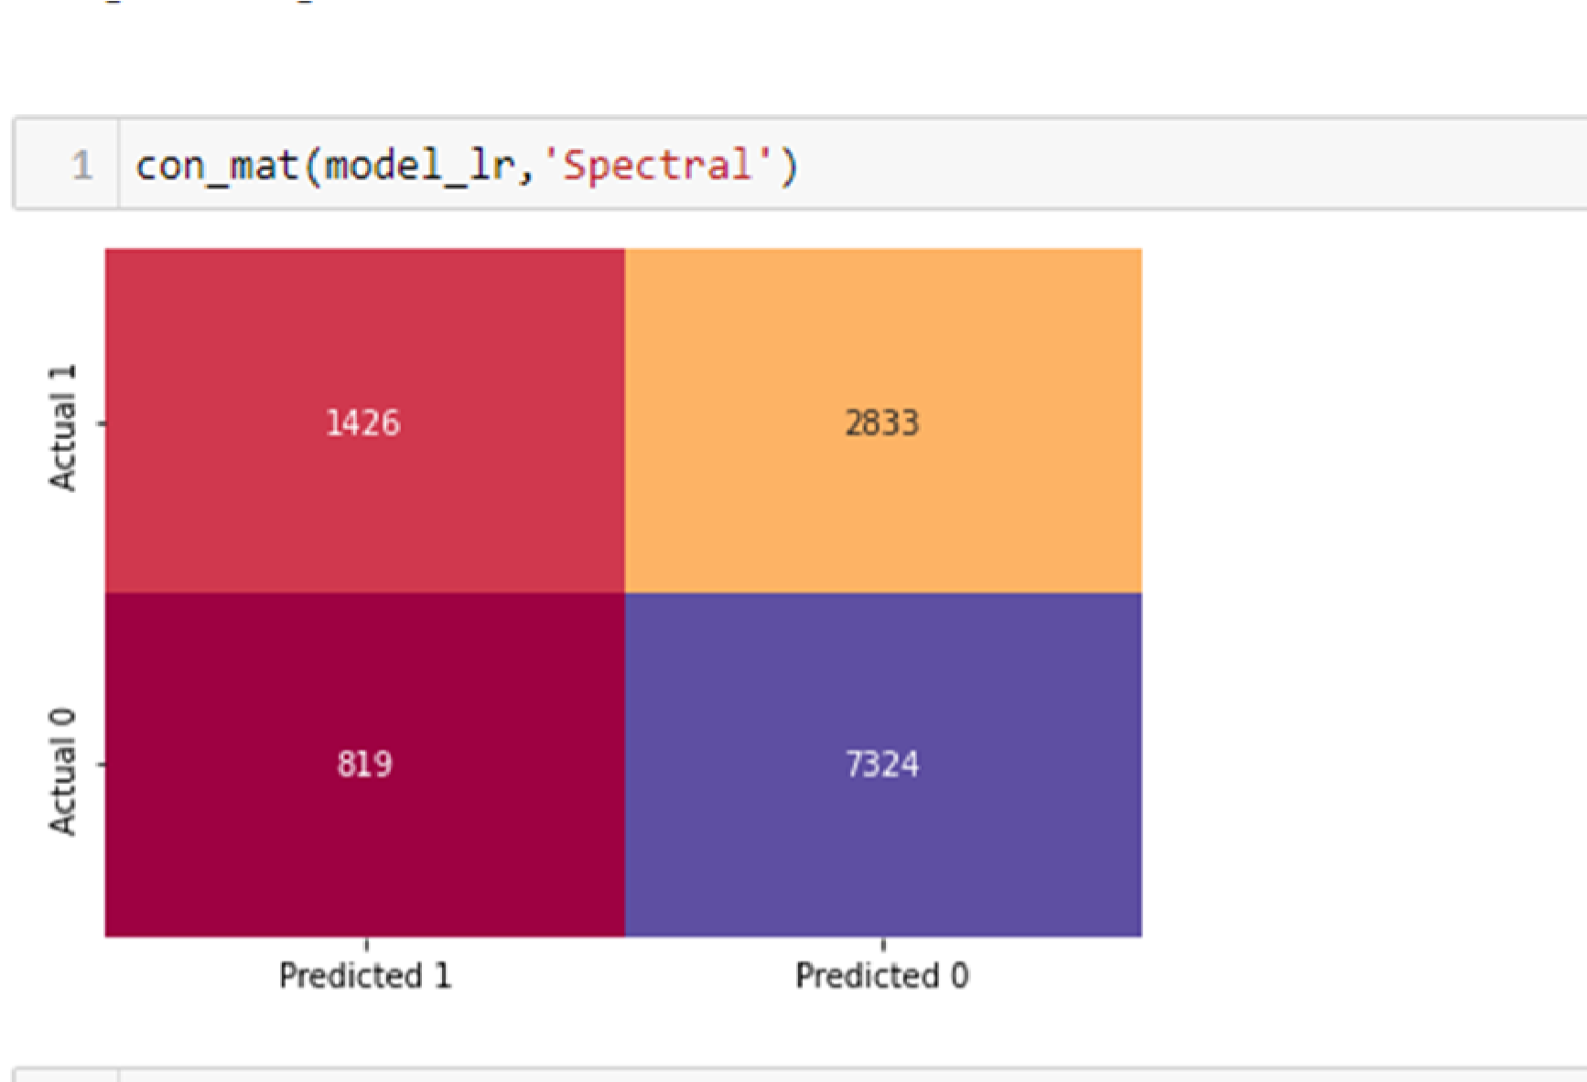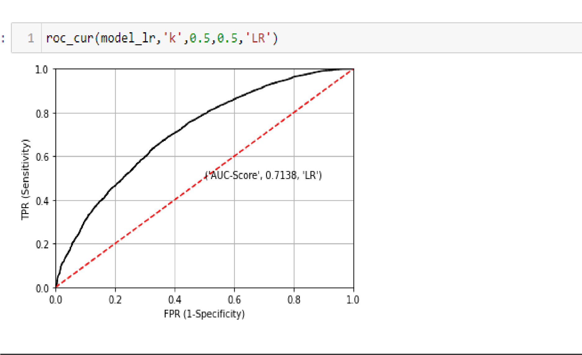

Step 8: Try to improve your metric by trying different models, changing the feature engineering methods, feature selection, etc.

Code:

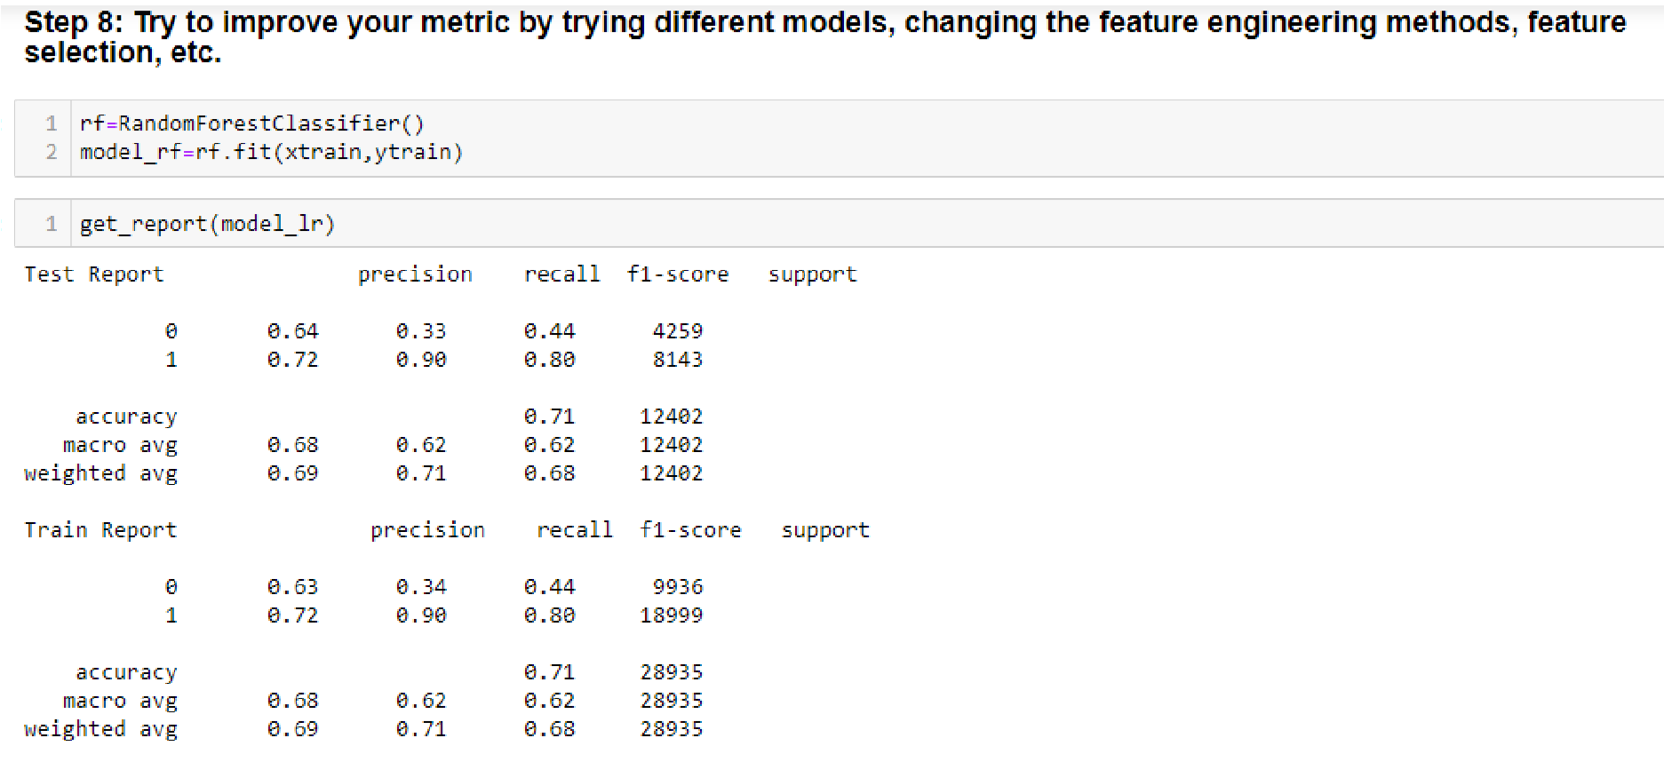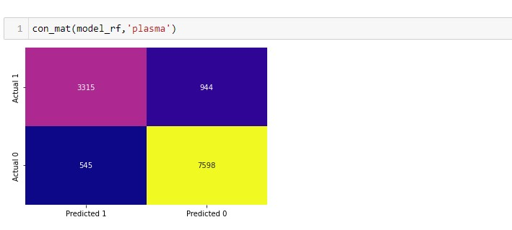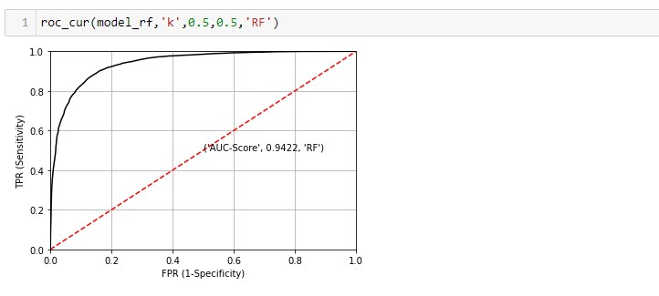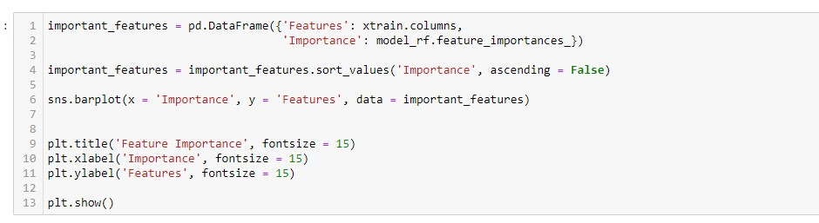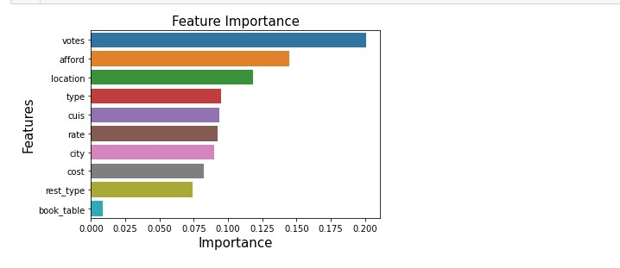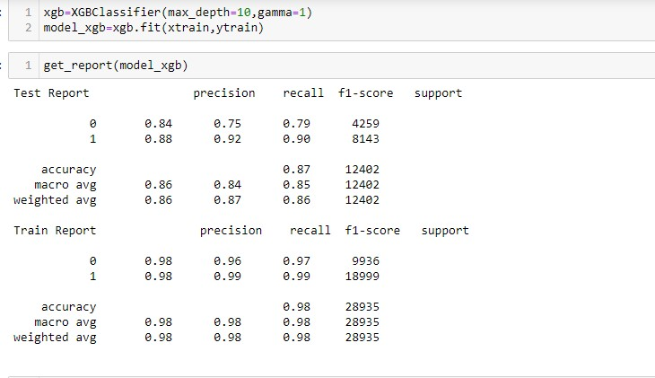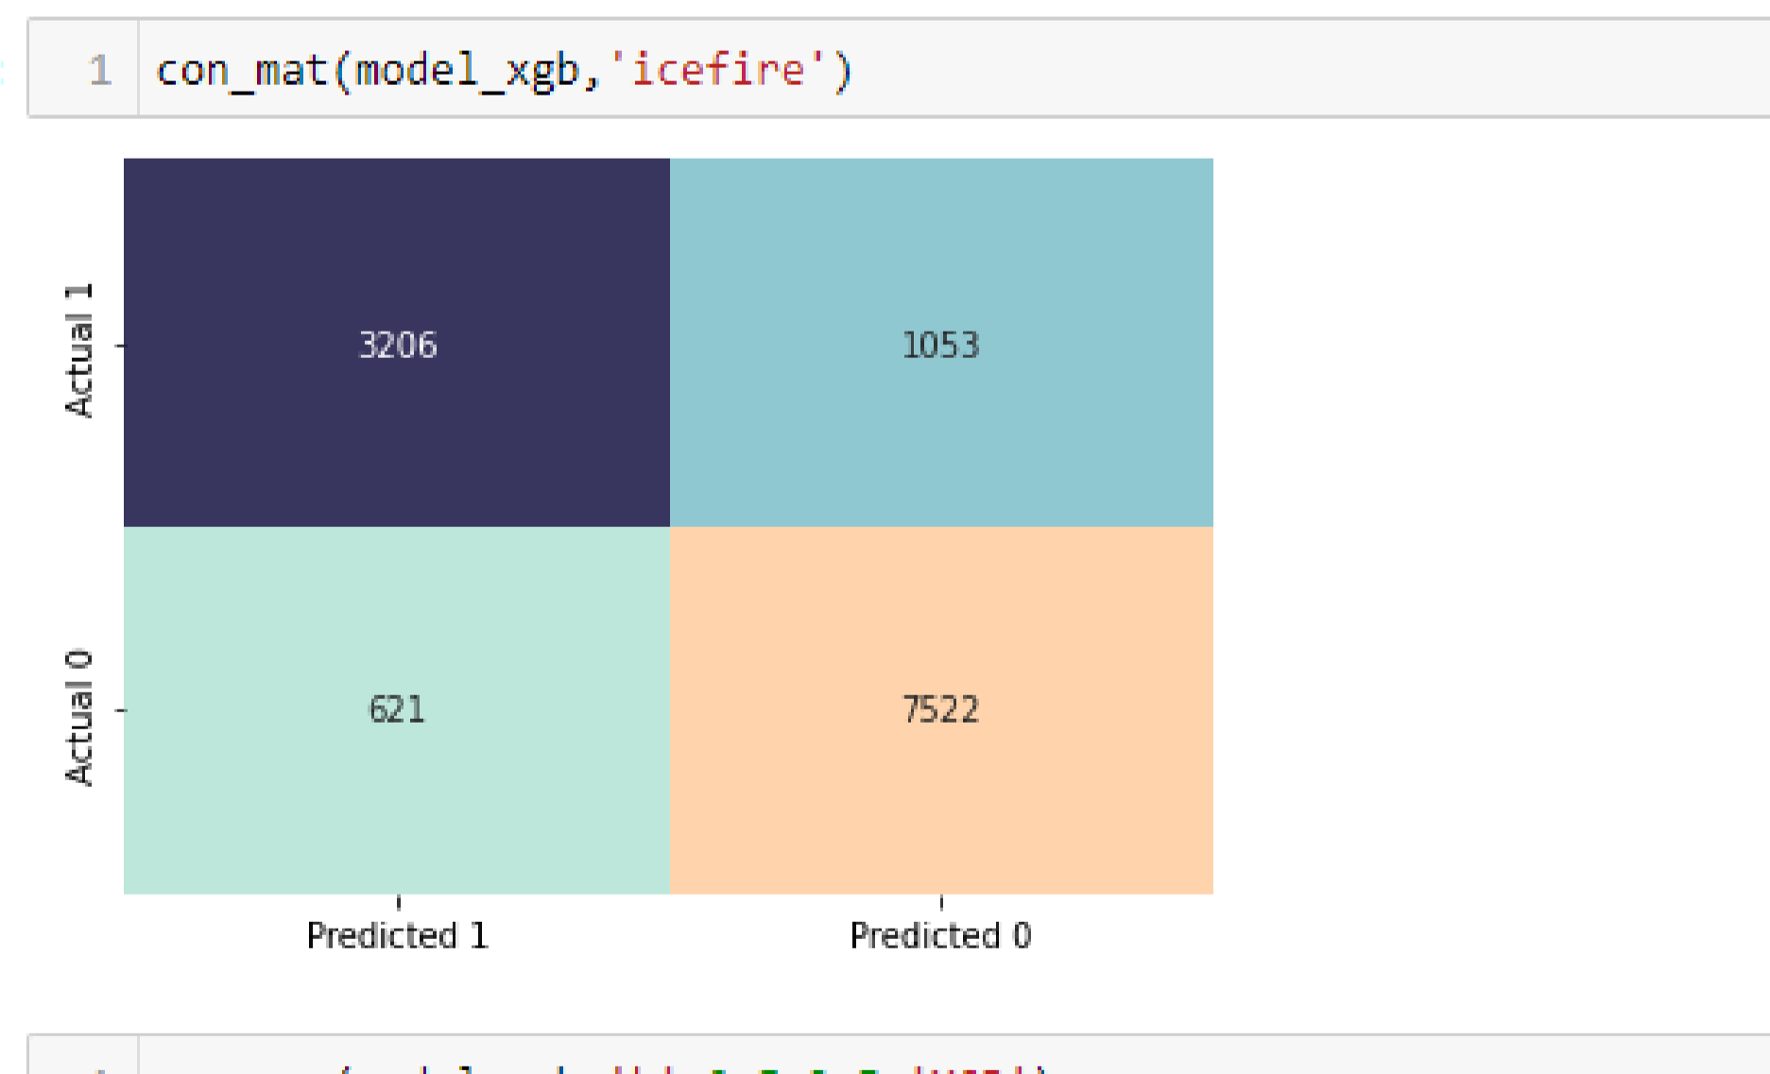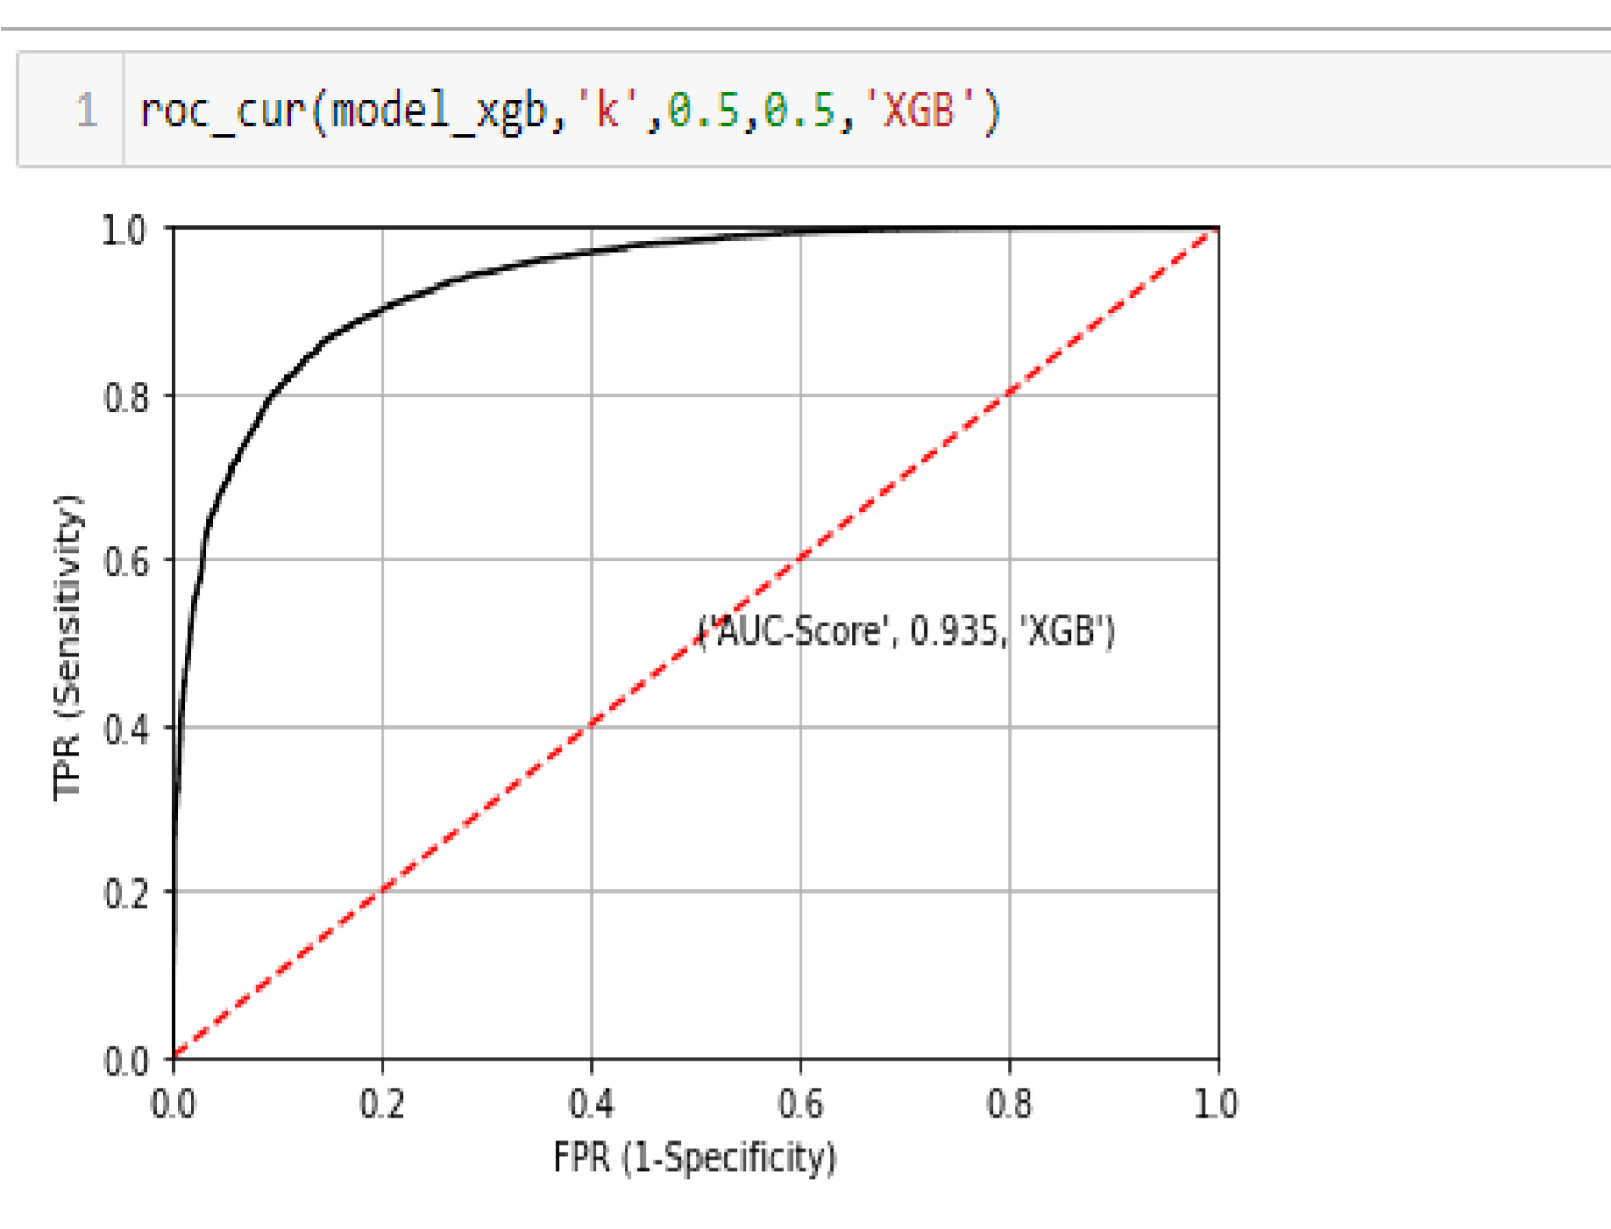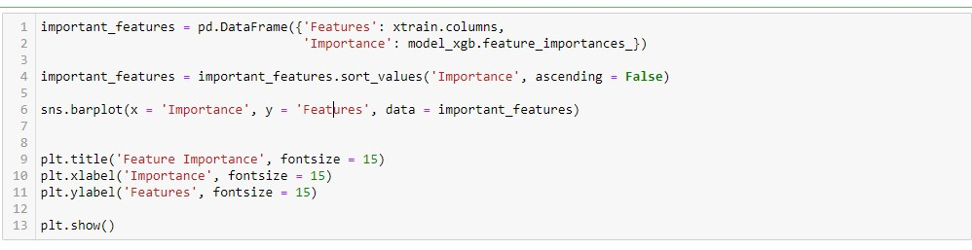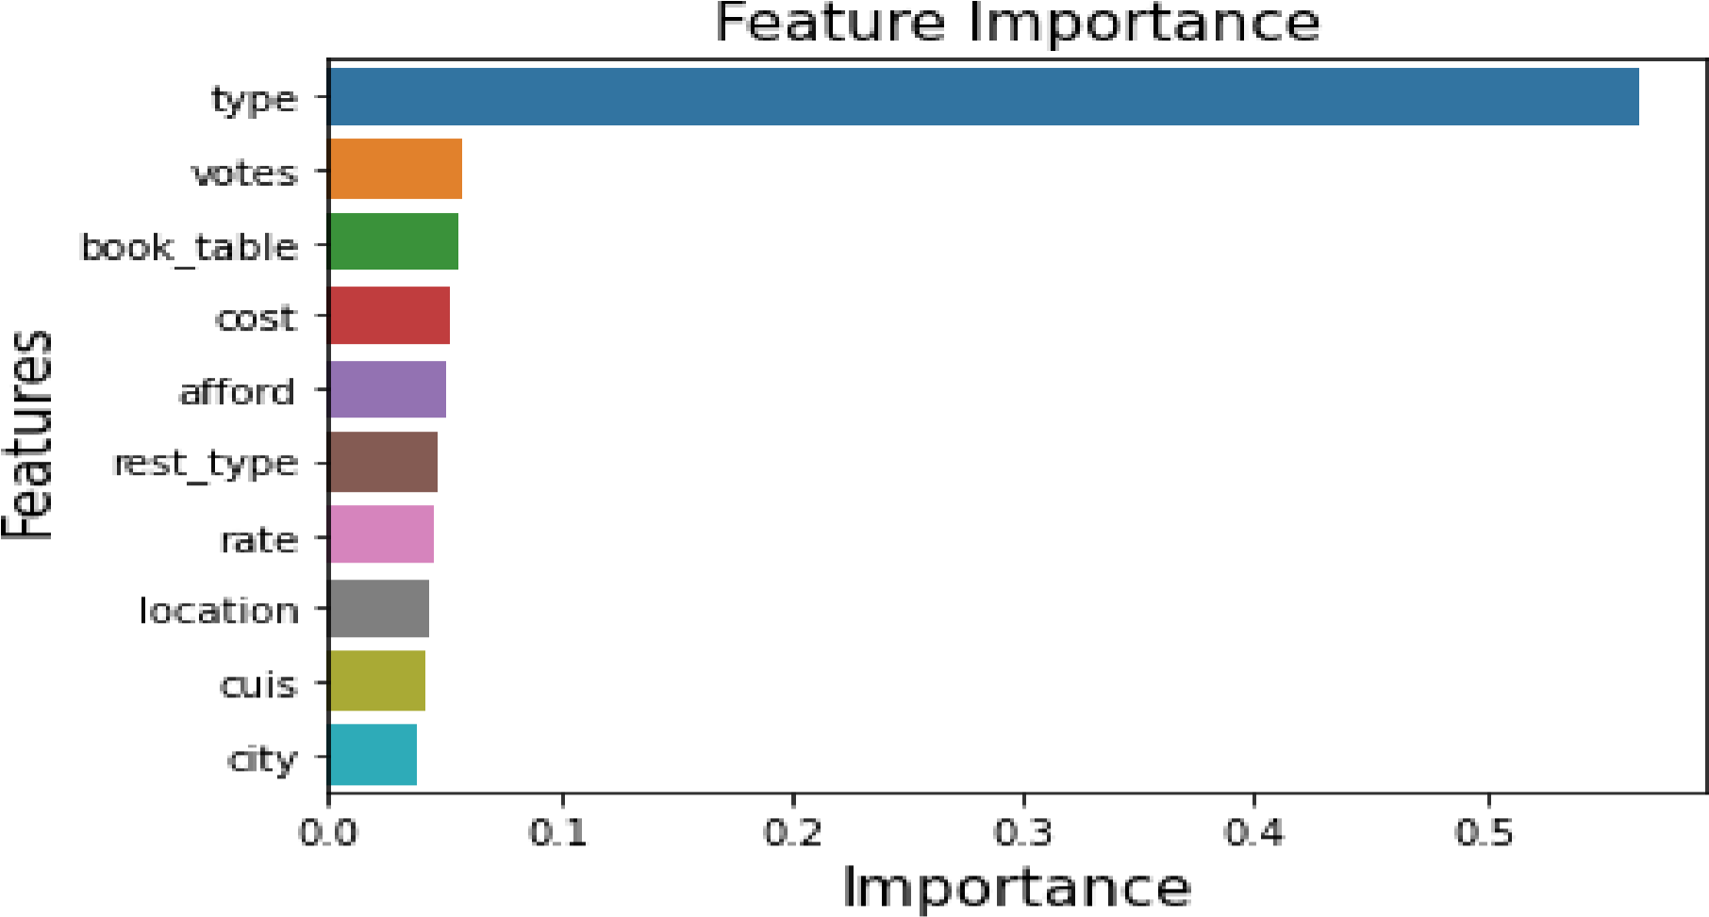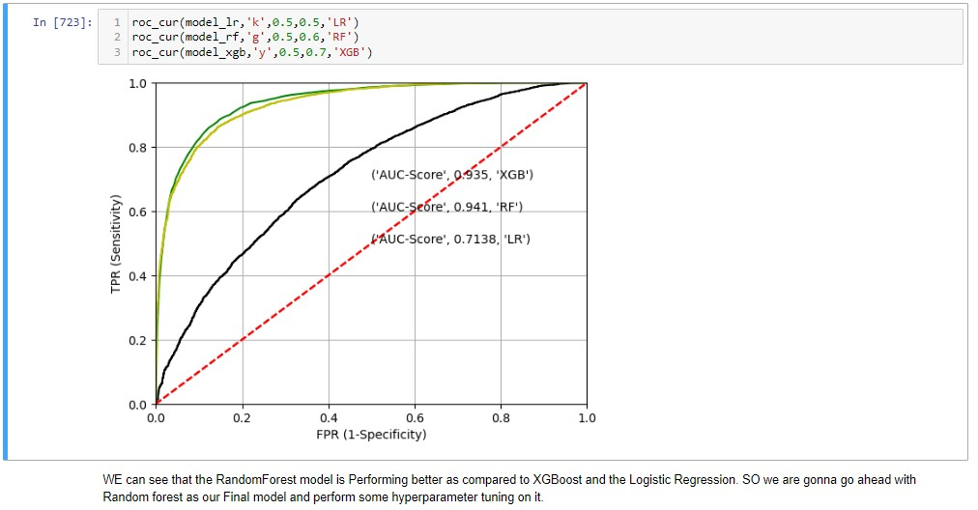

Step 9: Choose the final model and tune the model

Code:

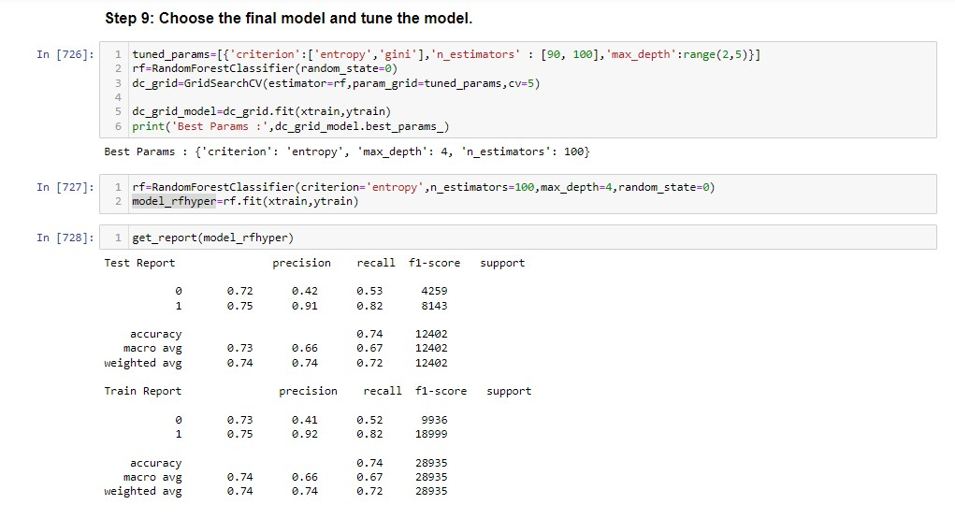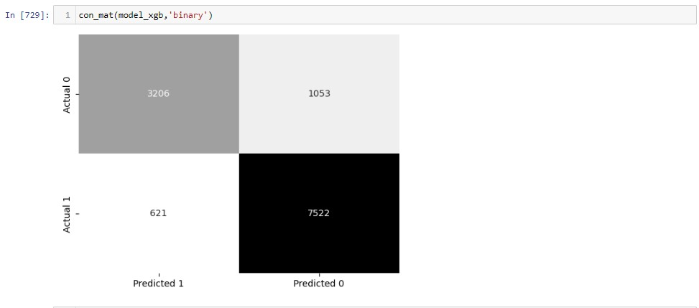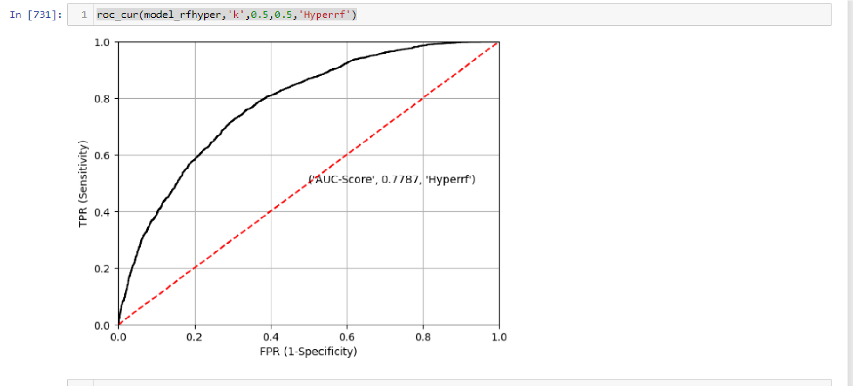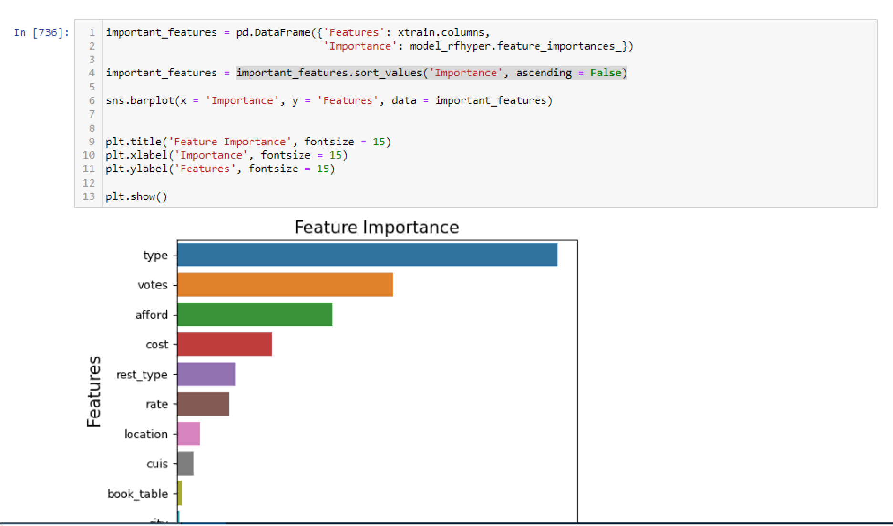

Step 10: Write your business interpretation. And explain the reasons behind choosing the final model and how the chosen modelperforms well compared to other models.

Code:

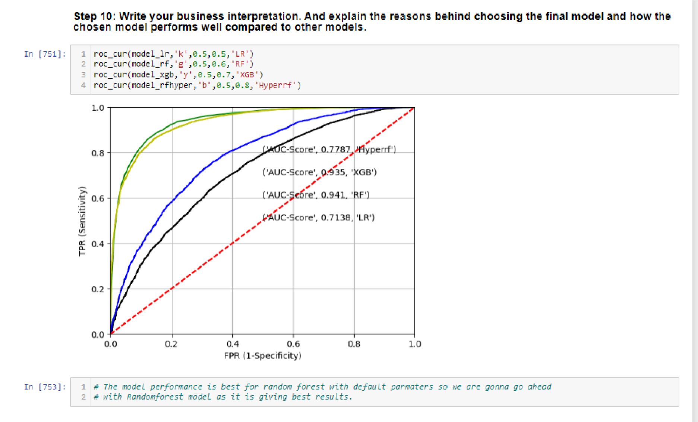

# Conclusion :

## Section A:

Bengaluru is a diverse city with a wide range of restaurants offering different cuisines and dining experiences. With over 12,000 restaurants and new ones opening every day, the food industry in Bengaluru is still growing. However, new restaurants face challenges in competing with established ones due to several factors.

One major challenge is high real estate costs, which can make it difficult for new restaurants to find affordable locations. Rising food costs are also a concern, as it can be challenging for new restaurants to maintain competitive prices while still providing high-quality food.

Another challenge is the shortage of quality manpower, which can make it challenging to provide consistent and efficient service. The supply chain can also be fragmented, with difficulties in sourcing high-quality ingredients and supplies. Finally, over-licensing can be a significant hurdle, with the licensing process being complicated and time-consuming.

To overcome these challenges, new restaurants in Bengaluru can consider the following strategies:

Seek out affordable real estate options - New restaurants can look for locations that are more affordable, such as in up-and-coming neighborhoods or areas outside of the city center.

Offer unique and high-quality dishes - By offering unique and high-quality dishes, new restaurants can differentiate themselves from established competitors. Build a strong team - By building a strong team of skilled and motivated employees, new restaurants can provide excellent service and attract more customers.

Build relationships with suppliers - New restaurants can work to build strong relationships with suppliers to ensure a reliable supply chain of high-quality ingredients and supplies.

Streamline licensing processes - By working with local authorities to streamline the licensing process, new restaurants can avoid unnecessary delays and costs. Overall, while the food industry in Bengaluru continues to grow, new restaurants face significant challenges. By implementing the above strategies, new restaurants can overcome these challenges and build a successful business in this competitive industry.

## Section B:

## Conclusion:

Based on the available information, it appears that Zomato is facing challenges with its offline orders, which is impacting its ability to attract customers with diverse items and offers. Additionally, the user subscription is also decreasing, indicating a need for further strategies to improve the online order process.

To address this problem, Zomato can consider the following strategies:

Offer incentives for customers to order online - Zomato can offer discounts or cashback offers for customers who place their orders online, which could encourage them to switch from offline to online orders.

Streamline the online order process - If Zomato can make the online order process faster and more user-friendly, it could attract more customers to place their orders online.

Increase the online menu offerings - Zomato can offer a wider range of menu items for online orders to attract customers who are looking for more diverse options.

Increase marketing efforts for online orders - Zomato can increase its marketing efforts to promote online ordering, through social media campaigns or email marketing to its user base.

Improve delivery services - Zomato can improve its delivery services for online orders, with faster delivery times, accurate order tracking, and better packaging to ensure that the food arrives in good condition.

Overall, by focusing on these strategies, Zomato can improve its online ordering process and increase customer satisfaction, which could ultimately lead to higher customer retention and revenue growth.

chain of high-quality ingredients and supplies.

Streamline licensing processes - By working with local authorities to streamline the licensing process, new restaurants can avoid unnecessary delays and costs.

due to several factors.

One major challenge is high real estate costs, which can make it difficult for new restaurants to find affordable locations. Rising food costs are also a concern, as it can be challenging for new restaurants to maintain competitive prices while still providing high-quality food.

Another challenge is the shortage of quality manpower, which can make it challenging to provide consistent and efficient service. The supply chain can also be fragmented, with difficulties in sourcing high-quality ingredients and supplies. Finally, over-licensing can be a significant hurdle, with the licensing process being complicated and time-consuming.

To overcome these challenges, new restaurants in Bengaluru can consider the following strategies:

Seek out affordable real estate options - New restaurants can look for locations that are more affordable, such as in up-and-coming neighborhoods or areas outside of the city center.

Offer unique and high-quality dishes - By offering unique and high-quality dishes, new restaurants can differentiate themselves from established competitors.

Build a strong team - By building a strong team of skilled and motivated employees, new restaurants can provide excellent service and attract more customers.

Build relationships with suppliers - New restaurants can work to build strong relationships with suppliers to ensure a reliable supply

Overall, while the food industry in Bengaluru continues to grow, new restaurants face significant challenges. By implementing the above strategies, new restaurants can overcome these challenges and build a successful business in this competitive industry.

**THANK YOU.......**